Read the question and answers below…

- Describe the advantages and disadvantages of soft engineering as a method of flood management (8 marks)

Answer A) Soft engineering can be quite cheap but it may not last as long as hard engineering. It may also not work as good as hard engineering. I can be good though as it’s environmentally friendly.

Answer B) Soft engineering has its advantages and disadvantages. It is a lot cheaper than hard engineering because it tends to be smaller scale. For example it cheaper to plant lots of trees (flood abatement) than to build a dam which costs millions (e.g. the 3 Gorges Dam in China).

Soft engineering also tends to be more aesthetically pleasing and more in keeping with the environment for example widening and deepening the river channel. This can also be a very effective form of flood management, however some forms of soft engineering have been criticised for being less effective and requiring more upkeep.

Another benefit of soft engineering is that it is more likely to be environmentally friendly. This is a particular concern with the increase in awareness about global warming. In flood zoning, for example, planners are able to restrict the use of flood planes for building on, which is cheap and reduces damage caused by flooding.

Draw a box around all of the geographical terms used in both answers
Underline the following words/phrases: because, for example, however
Highlight each type of soft engineering mentioned

Which answer do you think gained more marks?

…Remember, your answer should be full of examples, geographical terms and connectives.

- Describe the 3 effects of a flood (3 marks)

Answer A) Death of people, buildings destroyed, bridges broken
Answer B) Steep slopes, Heavy rain, Impermeable concrete town

Which answer states the effects of a flood?

…Remember, read the question. What is it asking you for?
Your turn…

- Explain the differences in the size and shape of the material on the river bed in the upper and lower courses of a river (Select A, B or C)

- In the upper course load is smaller and more rounded than in the lower course because of erosional processes such as attrition and corrasion.
- As a river moves through its course, because of the greater incidence of larger settlements, more supermarket shopping trolleys are likely to be found in rivers, adding to the load that has already been deposited.
- In the lower course load is smaller and more rounded than in the upper course because of erosional processes such as attrition and corrasion.

- What features are associated with waterfalls? (Select A, B or C)

- Niagara, Victoria, Angel, High Force.
- Plunge pool, undercutting, hard and soft rock.
- Weathering, erosion, transportation and deposition.

3. How long is the lag time shown on the hydrograph?

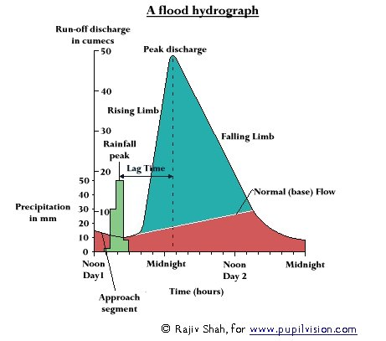
4. Describe the effects of a recent MEDC flood? (8 marks)

5. Give an example of a recent LEDC flood? (1 mark)

7. Describe the advantages and disadvantages of soft engineering as a method of flood management (8 marks)

