Water

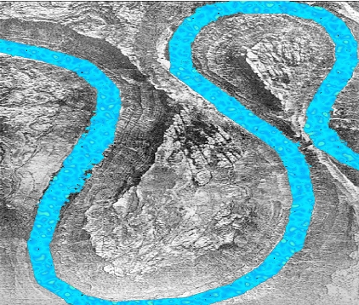

Learning Intentions:
1. What are river processes and what landforms do they create?
1.1 What processes are associated with rivers?
1.1 Explanation of river processes associated with erosion, transport and deposition.
1.2 What landforms result from these processes?
1.3 How do these landforms and processes affect the lives of
people living along rivers?
1.3 Case studies of development of tourism at major waterfalls and a major flood event.
2. How should rivers be managed?
2.1 How successful are different management approaches to the
problem of flooding? Comparison of hard and soft engineering.
2.2 Should we change our approach to river and floodplain management in the future?
http://www.thegeographyofblackwoodgcse.wikispaces.com
River Basin System Terms and Definitions

Look at the terms below. Link up the correct definition with the term, by writing the number at the end.

- Infiltration Deposition of water on to the Earth’s surface.
- Interception Process by which water enters into the soil.
- Transpiration The movement of water within a stream or river.
- Surface storage Water prevented from reaching the soil by vegetation.
- Evaporation Movement of water derived from precipitation.
- Groundwater flow Water that occupies pores and cavities within rocks.
- Percolation The downslope movement of water through the soil.
- Overland flow Downward movement of water within rocks.
- Stream flow Precipitation which reaches the ground through
vegetation.

- Throughfall Where water is held in the soil.
- Precipitation Process by which plants lose water vapour through
pores.

- Soil water Process in which water changes from liquid to gas.
- Groundwater Water stored on the ground surface.
- Throughflow Process by which water moves downwards through
cracks, joints and pores within soil and rock.

LETS PLAY TABOO!!

1.0 River Processes: The Hydrological Cycle
Fill in the diagram below by adding the key words from the list. Then, in the space below, explain how the hydrological cycle works.
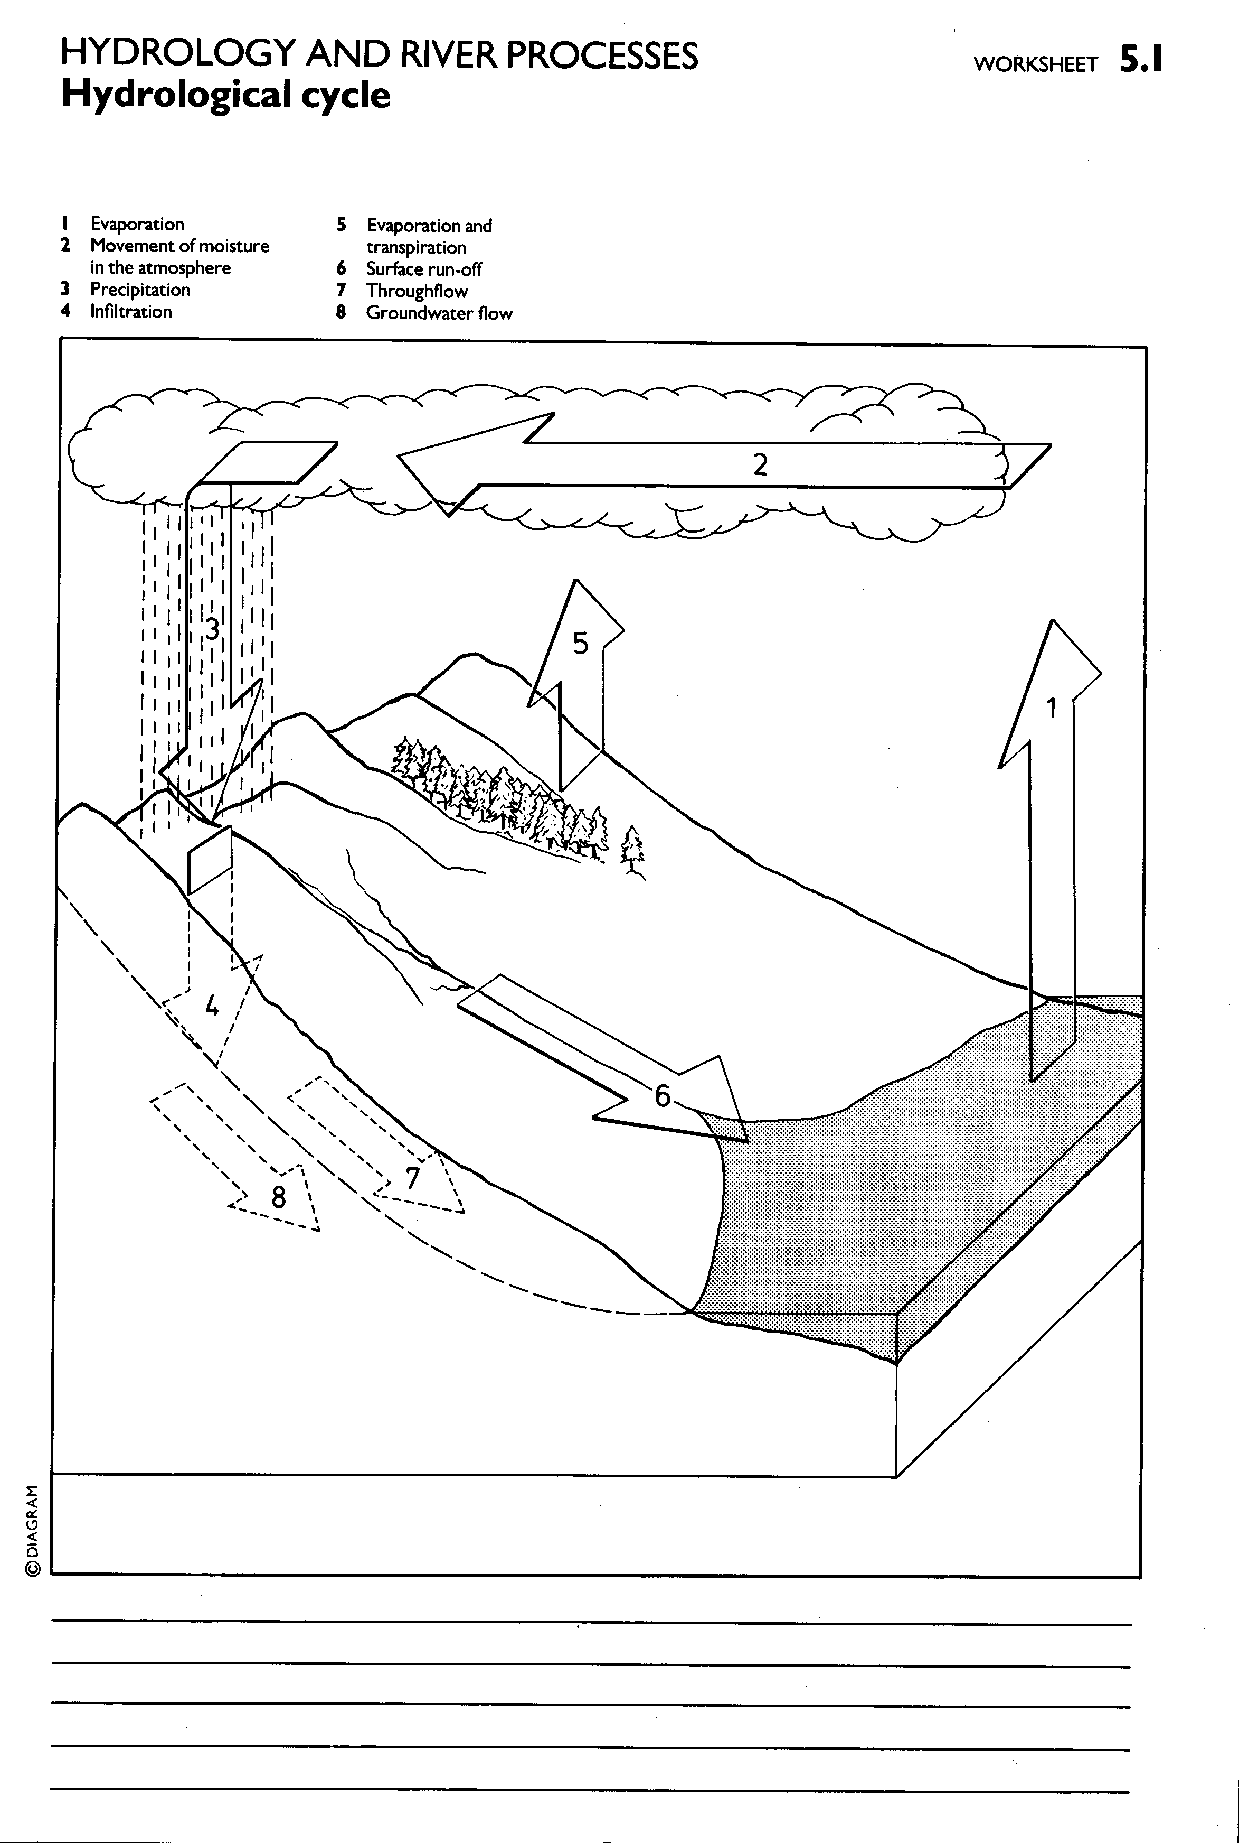
________________________________________________________________________________________________________________________________________________________________________________________________________________
1.1 River Processes- Erosion and Transportation

In the upper part of the river erosion dominates. A river can erode in one of four ways:
Hydraulic action | the sheer force of water hitting the banks of the river:
Abrasion (or corrasion) | fine material rubs against the riverbank The bank is worn away by a sand-papering action called abrasion, and collapses. This occurs on the out side of meanders.
Attrition | material is moved along the bed of a river, collides with other material, and breaks up into smaller pieces.
Solution (or corrosion) | rocks forming the banks and bed of a river are dissolved by acids in the water
Rivers can erode vertically and laterally, often at the same time. Vertical erosion occurs in fast flowing rivers where surplus energy allows down cutting to occur by the large bedload. This causes V shaped valleys with the river taking up most of the valley floor.. Further down the valley the river meanders across the floor causing lateral erosion. This can be seen when the valley floor is composed of alluvium and hydraulic action will cause the outside of the meander to collapse.
Once the material is erode it can then be transported by one of four ways, which will depend upon the energy of the river.
Traction | large rocks and boulders are rolled along the bed of the river.
Saltation | smaller stones are bounced along the bed of the river
Suspension | fine material which is carried by the water and which gives the river its 'muddy' colour.
Solution | dissolved material transported by the river

ODD ONE OUT Activity : River Processes

1. Meander | 2. Long Profile | 3. Gorge
4. Attrition | 5. Solution | 6. Sediment
7. Waterfall | 8. Abrasion | 9. Suspension
10. Saltation | 11. Bedload | 12. Flood Plain
13. Levee | 14. Discharge | 15. Velocity
16. Solution | 17.Hydraulic action | 18. V Shaped Valley
19. Erosion | 20. Deposition | 21. Transportation

The numbers below refer to the items in the table. THIS IS WHAT YOU HAVE TO DO

1.Guess the Odd One Out in each set.
2. Add in a fourth number from the table to match the other two
3. Write in what the link is between the three numbers.
Remember: there is not necessarily only one right answer.

 | 1 | 7 | 19
What’s the link?

 | 4 | 16 | 21
What’s the link?

 | 1 | 11 | 12
What’s the link?

 | 2 | 3 | 7
What’s the link?

Make up Your Own
What’s the link?
Characteristics of a river: River Long Profile

- Decide where the features are found – the upper or middle or lower course
- Explain why they are found in that part of the river profile?

Course of the River Feature Why found here?
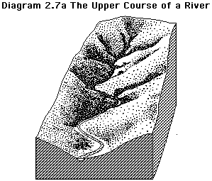

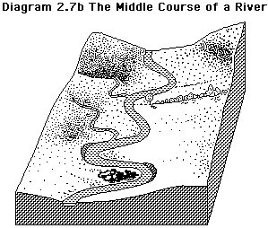

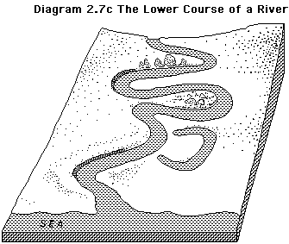

Summary: Changes in valley cross profile
The cross profile of a river valley is the result of the interaction with fluvial, weathering and slope (mass movement) processes.
We can se this in summary form in this diagram.
- in the upper course vertical erosion by the river forms steep V shaped valleys, with the river occupying all of the valley floor.
- lateral erosion forms wider valleys in the middle course,
- a wide flood plain signals the lower course where there is a lack of erosion and reduced competence, resulting in deposition
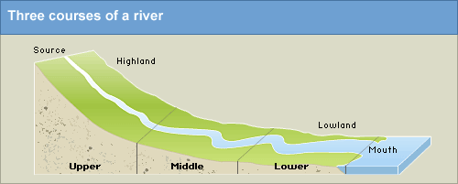
PUPIL TASK: Complete the table below?
 | UPPER COURSE | MIDDLE COURSE | LOWER COURSE
SPEED OF FLOW
SIZE AND SHAPE OF BEDLOAD
DISCHARGE OF RIVER
GRADIENT

1.2 River Landforms in the Upper Course:
Waterfalls and Gorges
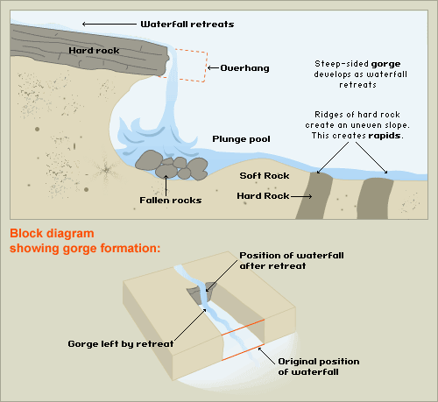
Pupil Task: In your own words, describe how a waterfall and gorge is created by a river in the upper stage.
__________________________________________________________________________________________________________________________________________________________________________________________________________________________________________________________________________________________
1.2 River Landforms in the Middle Course:
Meanders and Ox-Bow Lakes
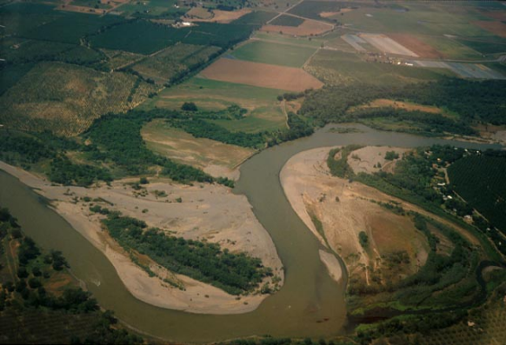
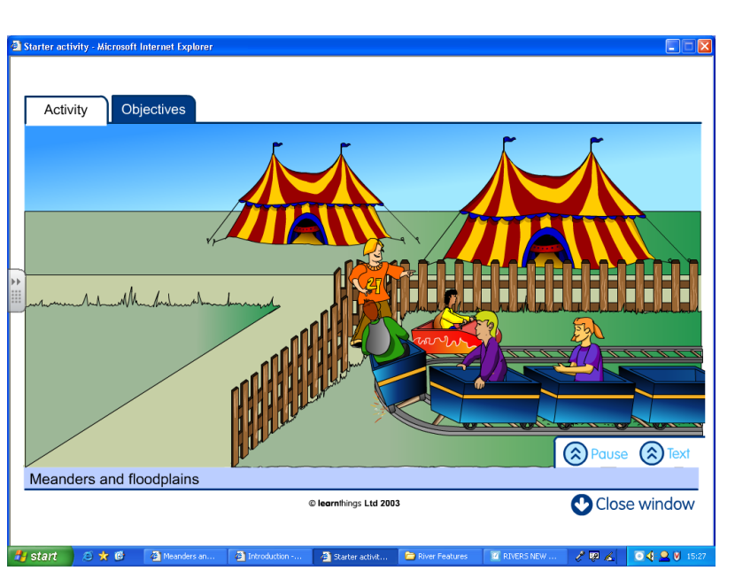

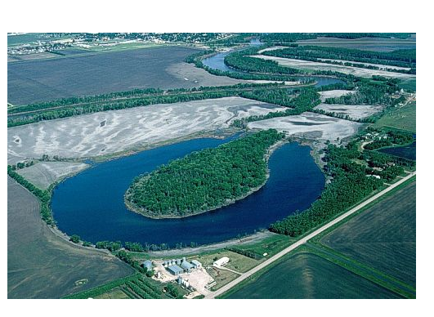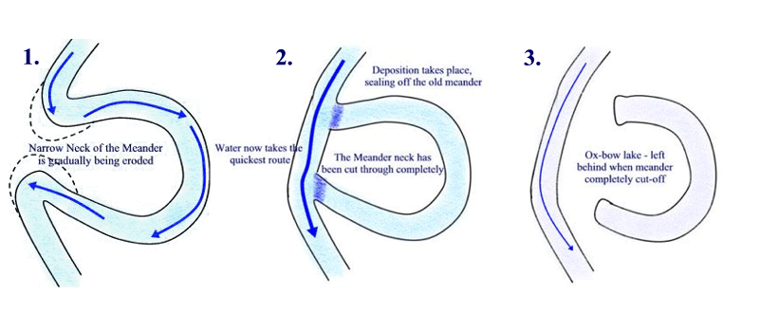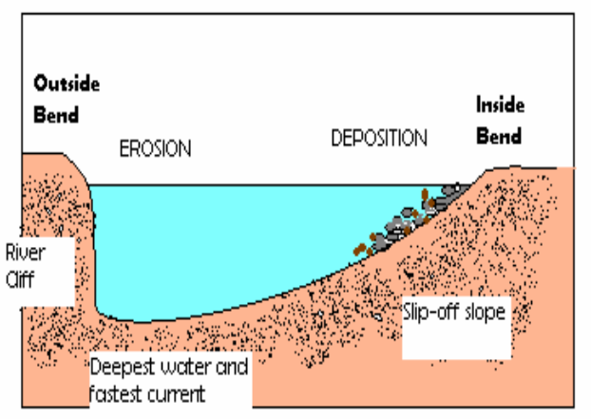
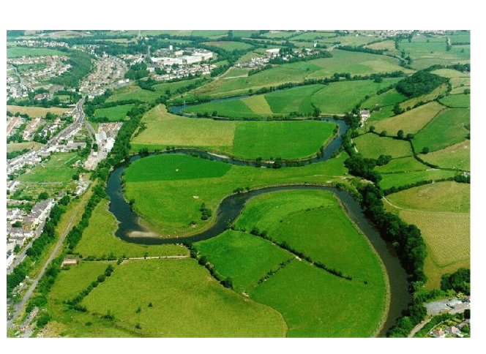
PUPIL TASK – explain the characteristics of meanders and ox-bow lakes. Use A4 lined paper and the diagrams above to help you construct your answer.
GOOD LUCK!

1.2 River Landforms in the Lower Course:
Floodplains and Levees
PUPIL TASK- In the space below, draw and explain the features of a floodplain and levee. You will need to research a suitable diagram and explain the characteristics of both landforms (written description).

