**Drainage basin system**

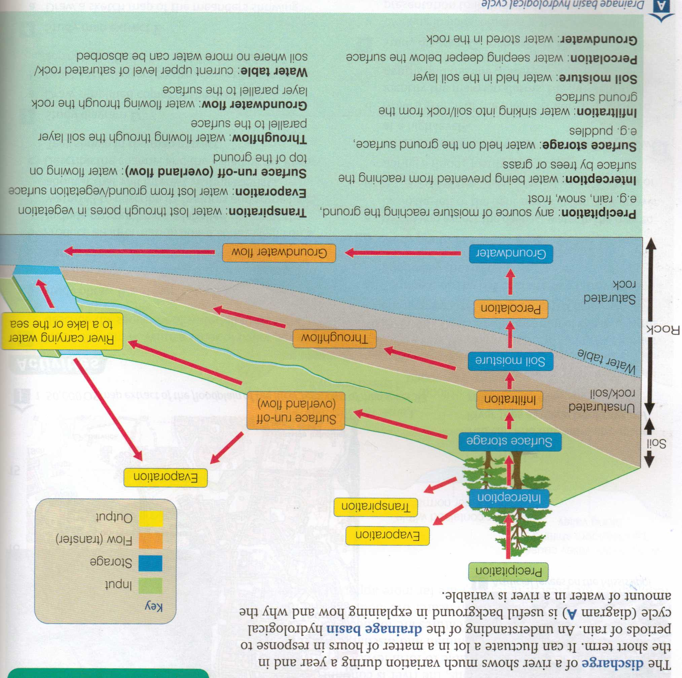

1. **The Storm Hydrograph**

The discharge of a river is shown on a graph called a **flood or storm hydrograph.** It shows the rainfall amount and then the discharge of the river. Most of the rain falls onto the land rather than directly into the river. The water then will make its way into the river and you can use a hydrograph to see how quickly this occurs. By looking at the peak rainfall and comparing it with the peak discharge you can work out the lag-time (the time between the two peaks).

Different catchment areas will have different flood hydrographs. Some, with steep slopes and little vegetation, will rise very quickly, and can be described as a **"flashy river"**. These are the most likely to flood.

Those drainage basins with shallower slopes and greater vegetation cover will infiltrate the water more, and release it at a slower rate into the river. This means there is less chance of flooding occurring.

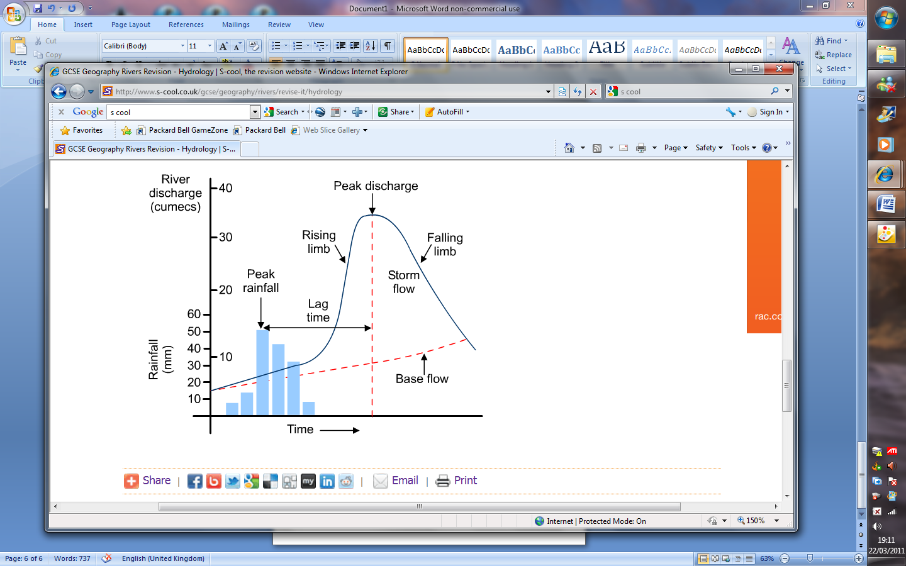

How would Vegetation affect the hydrograph?

How would Urbanisation affect the Hydrograph?

**The Boscastle Floods: August 16th 2004.**

**Causes:**

**Rain**

* A hot day in August (16th 2004)
* Really torrential thunderstorm 60 mms in two hours
* Really tall convectional clouds
* The remnants of Hurricane Alex

**Valley shape**

* Really steep sided deep valleys of the R. Valency and the R. Jordan
* The valleys funnel the water down towards Boscastle
* Small ‘flashy’ catchments that funnel water into rivers quickly. 23 sq. km.
* Rivers run off the high ground of Bodmin Moor (relief rainfall)

**Geology**

* Impermeable rocks (slates and granite) and clay soils

**Human**

* Boscastle built beside the sea on a flood plain at the end of the narrow river valleys.

**Effects:**

. Around 1000 residents and visitors are believed to have been affected in this devastating event.

• Miraculously, there were no fatalities, with only 1 reported casualty - a broken thumb.

• 7 helicopters airlifted 100 people (including 6 firefighters) to safety.

• 29 out of the 31 Cornwall County Fire Brigade stations were involved in the incident. They remained at Boscastle for 7 days, assisting in the clean-up operation.

• 58 properties were flooded, 4 of which were demolished including The Visitor Centre,

• A further 40 properties were flooded in other villages

• 4 footbridges along the Valency Valley were washed away.

• 84 wrecked cars were recovered from Boscastle’s harbour and streets, 32 could still be out at sea.

• The infrastructure damage to buildings and services, could cost up to £2 million.

**Future Prevention Measures**

* Seen as very exceptional – once in 400 year event – so less need to act!
* No-one actually killed (unlike Lynmouth) – so less need to act!
* Most of the inhabitants of Boscastle are under no illusion, from past experience the village may well witness further floods in the future, but hopefully not on this scale.
* Preventative measures and improvements by the Environment Agency are already under way. They include a new culvert on the River Jordan, upstream of the Wellington Hotel, extending a further 80minto the River Valency.
* Discussions concerning flood risk management in the upper Valency catchment area were also taking place, but no conclusions have yet been reached on further works in Boscastle.

**Causes of floods in LEDCs**

Bangladesh is one of the world’s poorest countries. Nearly all of its 120 million people live in the countryside and rely on intensive rice farming for their livelihood.

**Location and physical landscape:**

The country lies on the northern end of the Bay of Bengal and at the mouth of several large rivers. About 80% of Bangladesh consists of the flat low lying floodplain and deltas of the rivers Ganges, Brahmaputra (called the Jamuna in India) and Megna (see map below). These rivers play a major role in Bangladesh and bring severe flooding every year, although they are not the only source of flooding.

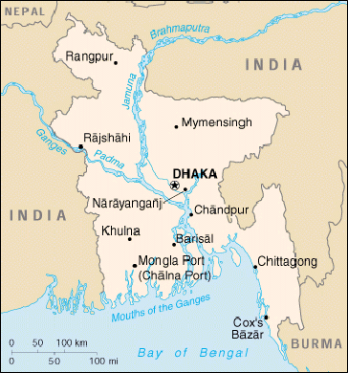

**Causes of flood**

There are **four** main causes of flooding in Bangladesh:

|  |
| --- |
| **1) Heavy monsoon rainfall**  **2) Snowmelt from Himilayas**  **3) Deforestation in the Himilayas**  **4) Excessive urbanization** |

***Monsoon downpour:***

*An increased amount of precipitation can cause flooding. An above normal monsoon downpour in the Ganges-Brahmaputra-Megna drainage system is thought to be the primary cause of the 1988 flood in Bangladesh. It is not known, however, if the heavy precipitation is actually an effect of other processes such as the greenhouse effect or destruction of forests in the upstream region.*

***Snowmelt in the Himilayas***

The Himilayas are one of the few places in the world that retain permanent glaciers. In the warmer summer season however glacial ice goes through a period of melt The source of the Brahmaputra starts in the Himilayas and an increase in meltwater flowing through its drainage basin will increase channel flow, saturate soils and cause massive overland flow – a major cause of flooding.

**Deforestation**

Increasingly frequent flooding in Bangladesh is attributed to the removal of trees in the forests of Nepal and other Himilayan areas. A rapid increase in population in the Indian Subcontinent over the course of the present century has resulted in a acceleration of deforestation in the hills of Nepal to meet the increasing demand for food and fuel wood . Deforestation of steep slopes is assumed to lead to accelerated soil erosion and landslides during monsoon precipitations. This in turn is believed to contribute to devastating floods in the downstream regions such as in Bangladesh

**Excessive Development:**

Rapid population growth creates extra pressure on the land of already overcrowded Bangladesh. Agricultural lands give way to housing developments and roads. This rapid development and urbanization must have aggravated the flooding problem in Bangladesh. Prior to urbanization there is a greater lag time between intense rainfall and peak stream flow. After urbanization the lag time is shortened, peak flow is greatly increased, and total run-off is compressed into a shorter time interval favorable conditions for intense flooding. For example, in a city that is totally served by storm drains and where 60% of the land surface is covered by roads and buildings, floods are almost six times more numerous than before.

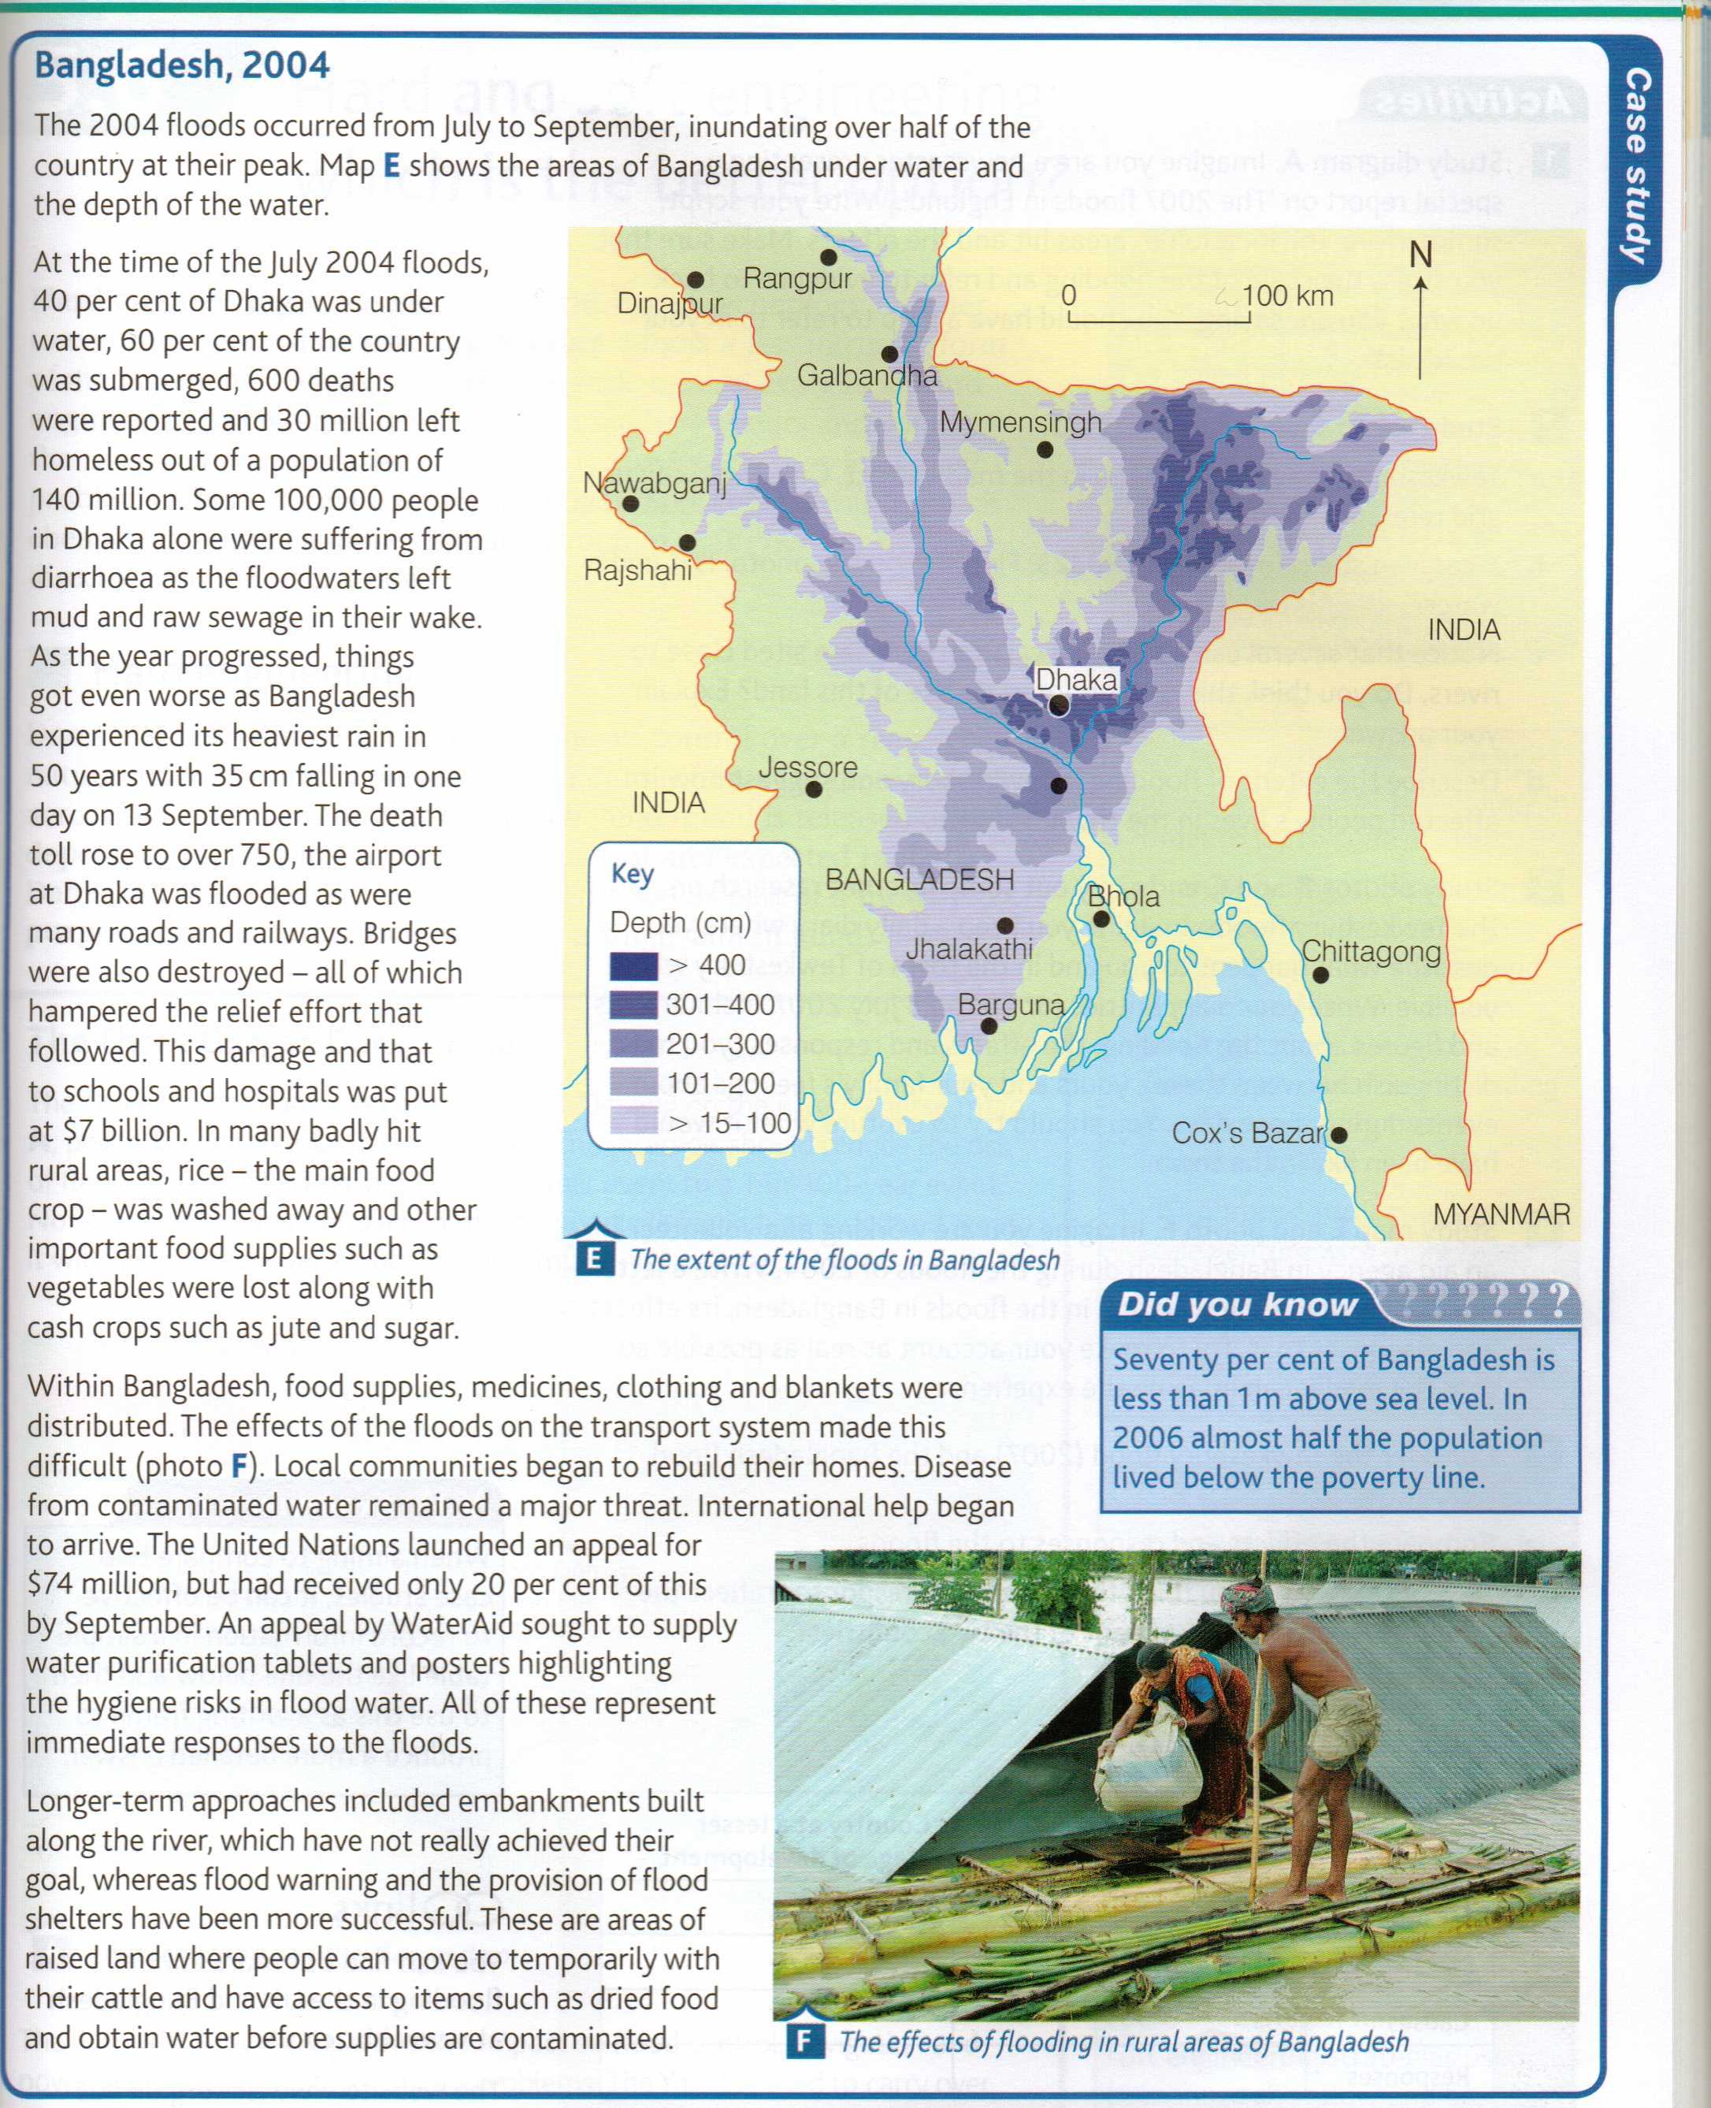

**River management**

**Hard engineering options**

|  |  |
| --- | --- |
| **Dam construction** | * Dams are often built along the course of a river in order to control the amount of discharge. Water is held back by the dam and released in a controlled way. This controls flooding. * Water is usually stored in a reservoir behind the dam. This water can then be used to generate hydroelectric power or for recreation purposes. * Building a dam can be very expensive. * Sediment is often trapped behind the wall of the dam, leading to erosion further downstream. * Settlements and agricultural land may be lost when the river valley is flooded to form a reservoir. |
| **River engineering** | * The river channel may be widened or deepened allowing it to carry more water. A river channel may be straightened so that water can travel faster along the course. The channel course of the river can also be altered, diverting floodwaters away from settlements. * Altering the river channel may lead to a greater risk of flooding downstream, as the water is carried there faster. |

**Soft engineering options**

|  |  |
| --- | --- |
| **Afforestation** | * Trees are planted near to the river. This means greater interception of rainwater and lower river discharge. This is a relatively low cost option, which enhances the environmental quality of the drainage basin. |
| **Managed flooding** | * The river is allowed to flood naturally in places, to prevent flooding in other areas - for example, near settlements. |
| **Planning** | * Local authorities and the national government introduce policies to control urban development close to or on the floodplain. This reduces the chance of flooding and the risk of damage to property. * There can be resistance to development restrictions in areas where there is a shortage of housing. Enforcing planning regulations and controls may be harder in LEDCs. |

**Case study of Hard Engineering**

Gorges Dam project.

The Three Gorges Dam is the most famous and most gigantic project of the world. But, everything has two sides, so here we present the advantages and disadvantages of China's Three Gorges Dam, namely its pros and cons.

Supporters say the benefits of the project far outweigh the costs. The principal advantage of the project is to generate power to keep pace with China's economic growth. It is estimated that China's power output must rise by 8 percent annually to keep pace with 6 percent annual increase in gross national product.

In practical term, that means the nation's total 1990 power capacity of 130 million kilowatts must grow to 580 million by the year 2015.

**Advantages**

1**. Flood Control**. Chinese officials note that the dam will relieve the danger of flooding.

2**. Emissions reduction**Another advantage of the dam is to reduce emissions of sulphur dioxide and carbon dioxide.

3. China is enforcing tight rules aimed at preventing construction work from causing environmental pollution, while advanced facilities are being installed to treat construction waste. By the year 2000, over 90 percent of waste water from construction is expected to be treated.

**Disadvantages**

1. **Relocation** Chinese officials estimate that the reservoir will partially or completely inundate 2 cities, 11 counties, 140 towns, 326 townships, and 1351 villages. About 23800 hectares, more than 1.1 million people will have to be resettled.

2. It will threaten the river's wildlife. The dam will alter the natural environment, and therefore, an almost infinite number of species will be affected by the project.

3. The Three Gorges project will submerge some of China's most famous historical scenery and tourist sites.

4. The weight of millions of tons of water behind a dam can increase the chances of an earthquake.

5. The dam will disrupt heavy silt flows in the river. It could cause rapid silt build-up in the reservoir, creating an imbalance upstream, and depriving agricultural land and fish downstream of essential nutrients.

Advantages/Disadvantages of soft engineering

There are several advantages of soft engineering compared to hard engineering. Soft engineering makes use of ecological principles and practices, by using living structures for construction. This means that it will not harm the wildlife, and rather, protect it. It is cheaper to construct compared to hard engineering, as it makes use of what is already available in the natural world. Moreover, it requires less long-term maintenance costs due to the fact that the living structures used mature and stabilize over time to reduce erosion. It also improves ecological features and provides opportunities for recreational activities like fishing.

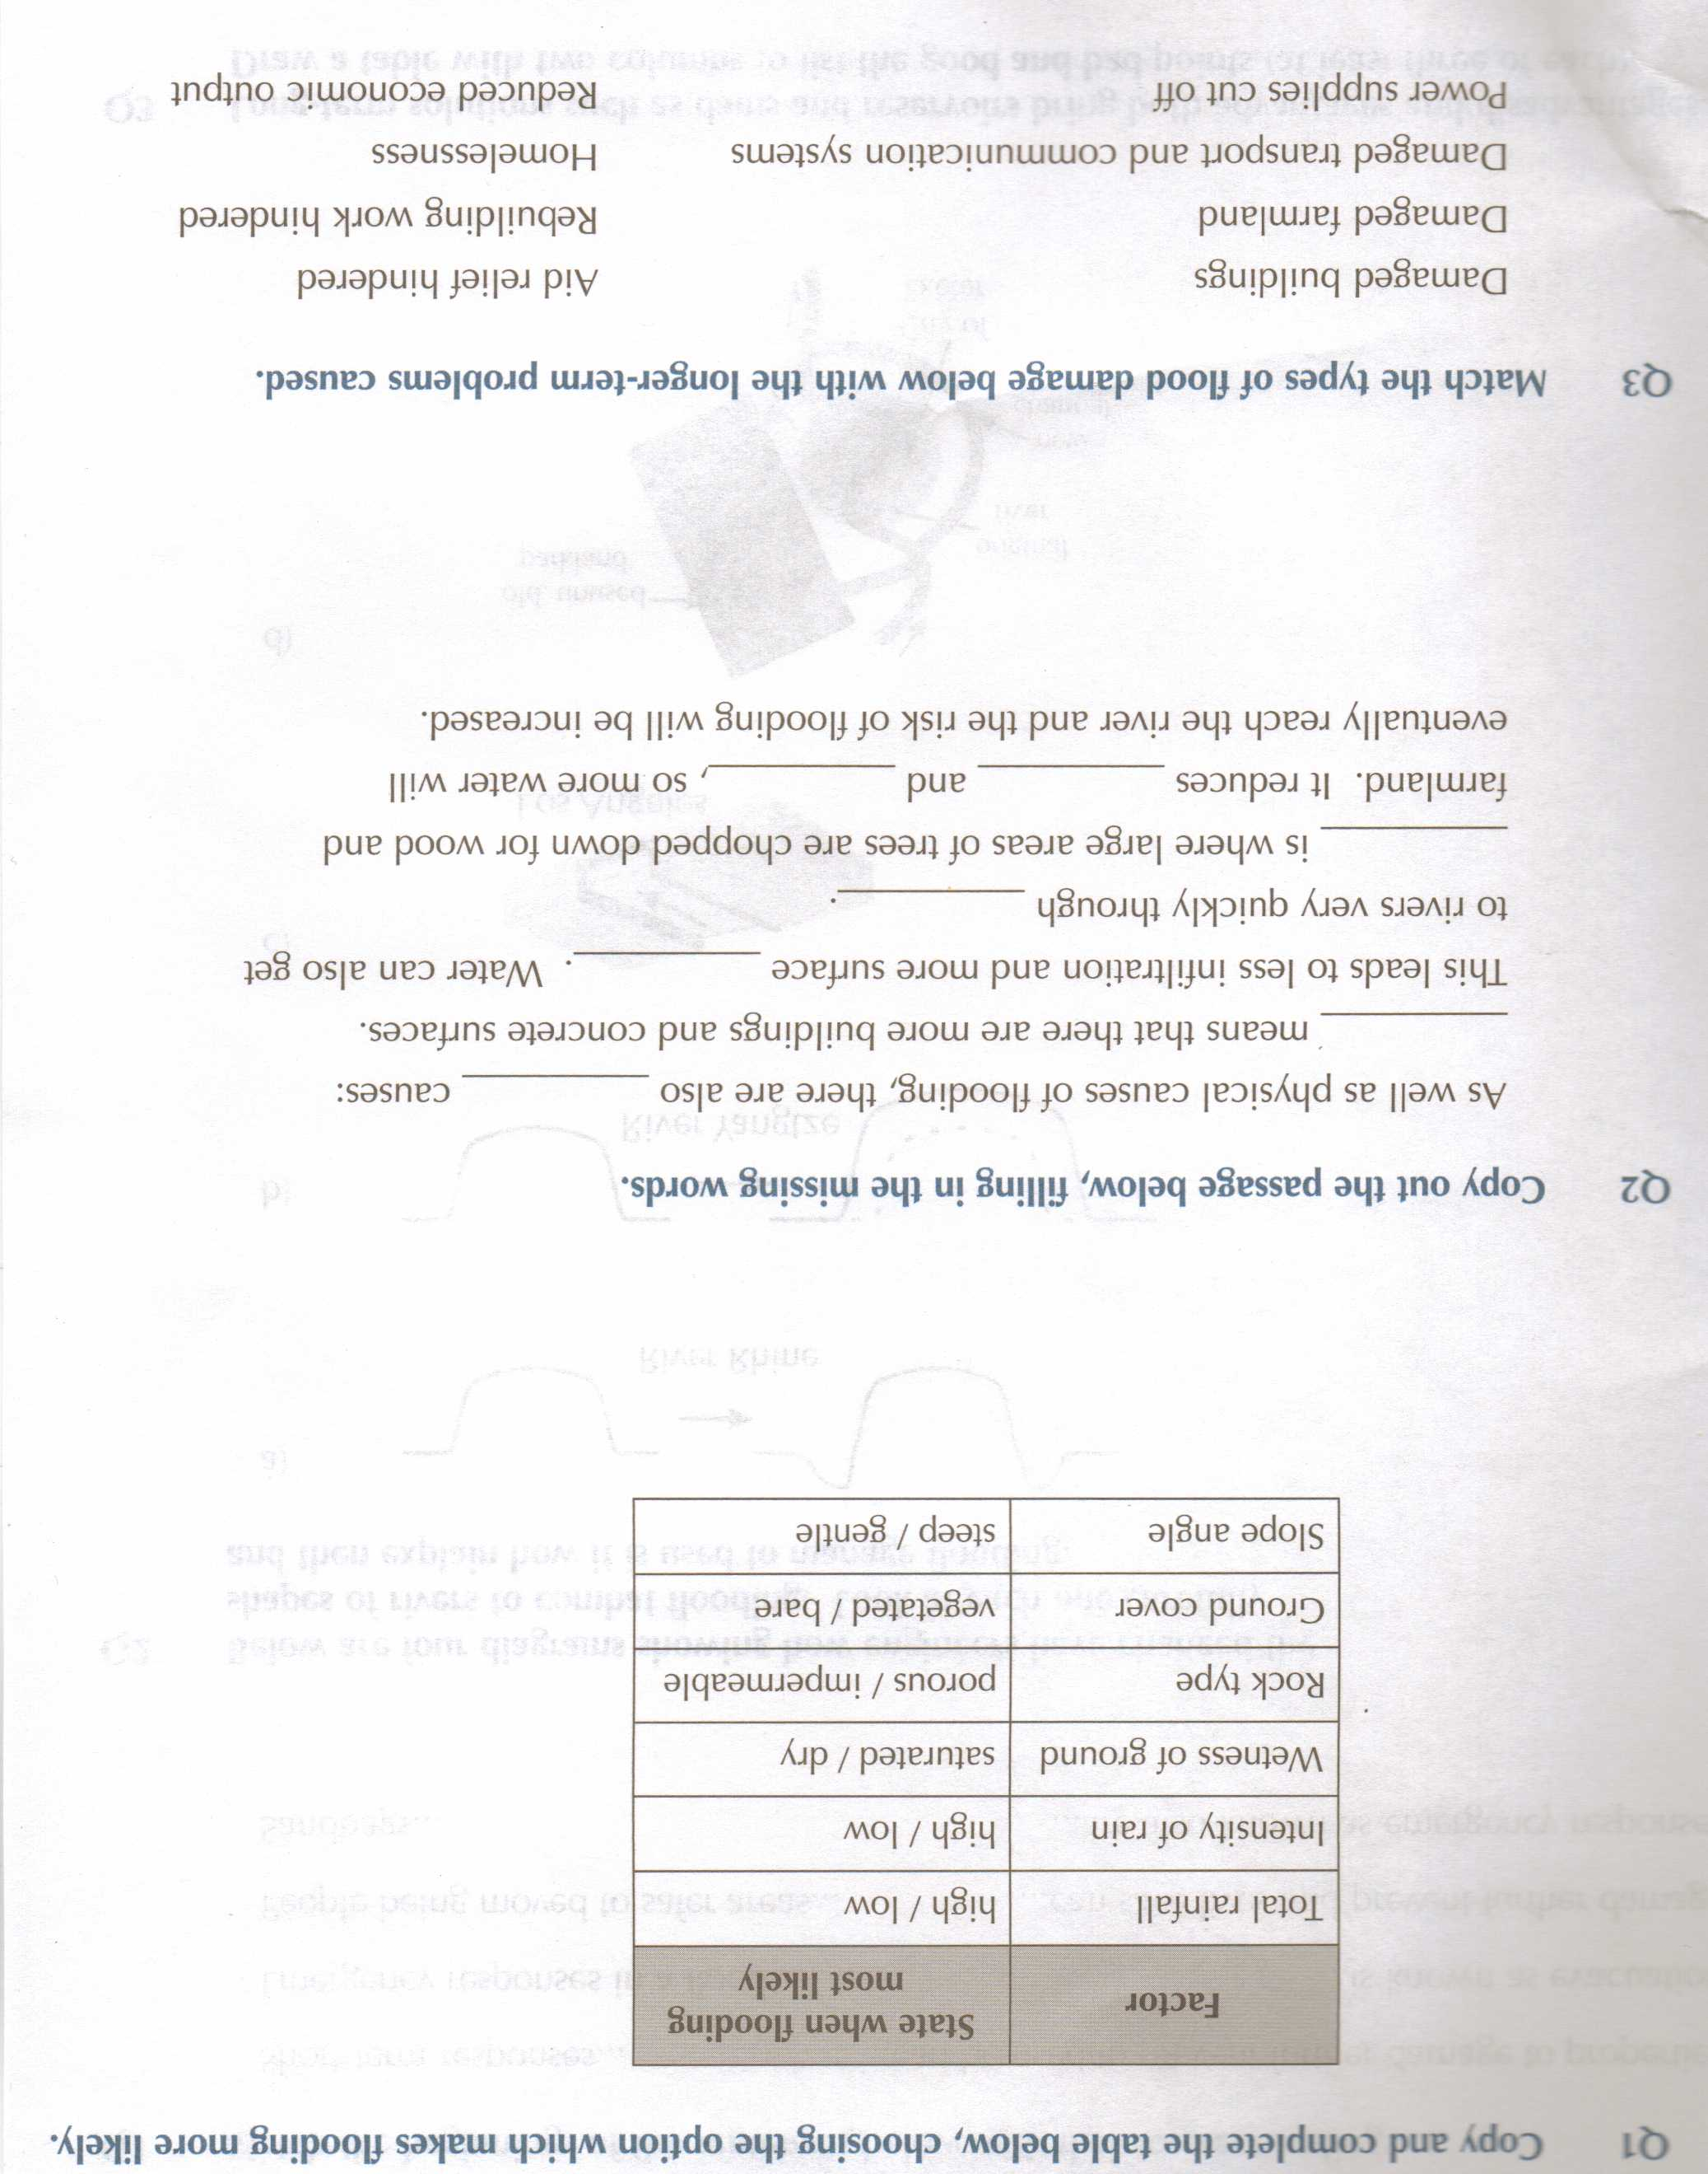

AQA GCSE Geography A

**Rivers - Practice Paper**

Attempt this paper after revising well, using this revision guide/textbook/your notes

**Study leave**

63 min

44 marks

*Good Luck - Mr V :)*

**1.** Tick the correct box to show whether or not each of the following is a process of river transport.

**True** **False**

Traction  

Corrosion  

Suspension  

(Total 3 marks)

**2.** Study the figure belowwhich shows some features of the lower course of a river.



(i) On the figure above, mark with an arrow and label:

**delta**

**ox-bow lake.**

(2)

(ii) Complete the paragraph below to explain how levées are formed.  
Choose the correct words from this list.

**valley** **deposit** **channel** **velocity**

**fences** **level** **erode** **banks**

When a river overflows, the .................................. decreases and it begins to

.................................. its load, the largest material first. After repeated

floods, high .................................. called levées are formed at the sides of the

river. If the river floods in the future, the effects could be severe as the water

cannot drain back into the .................................. .

(4)

(Total 6 marks)

**3.** Study the photograph below of the upper course of the Yellowstone River, USA.

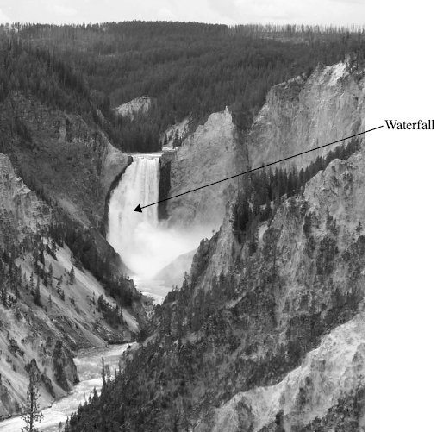

(i) On the photograph above, a waterfall has been labelled.

Mark with an arrow and label **three** other features of the river and its valley in its upper course.

(3)

(ii) Explain the formation of a waterfall.

.....................................................................................................................................

.....................................................................................................................................

.....................................................................................................................................

.....................................................................................................................................

.....................................................................................................................................

.....................................................................................................................................

.....................................................................................................................................

.....................................................................................................................................

.....................................................................................................................................

.....................................................................................................................................

.....................................................................................................................................

.....................................................................................................................................

(6)

(Total 9 marks)

**4.** The figure belowshows the stages in the formation of a river landform in its lower course.

Add a sentence in each box to explain the formation of the landform.

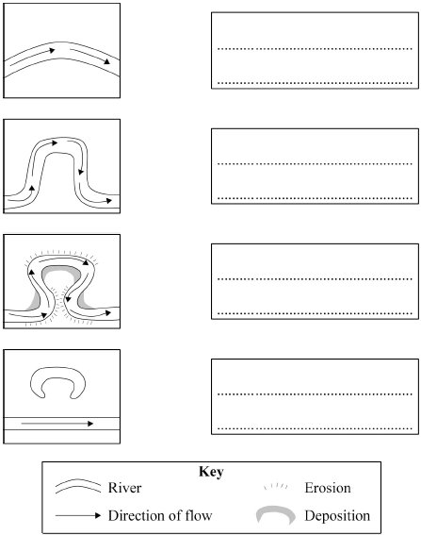

(Total 4 marks)

**5.** Belowis a sketch-map of part of Ross-on-Wye.



(i) On the figureabove, mark with an arrow and label the following:

**meander  
tributary  
flood plain**

(3)

(ii) What is a levée?

.....................................................................................................................................

.....................................................................................................................................

(1)

(iii) Complete the sentences below to explain how a flood plain is formed.  
Choose the correct words from this list.

**migrate** **corrosion** **outside** **flows**

**attrition** **inside** **floods** **retreat**

Hydraulic power and ................................................ erode the

................................................ bend of a meander. The meanders also

................................................ downstream. When the river

................................................ , silt and sand are deposited which build

up the flood plain.

(4)

(Total 8 marks)

**6.** Study the photograph below showing the effects of the floods in Boscastle in 2004.

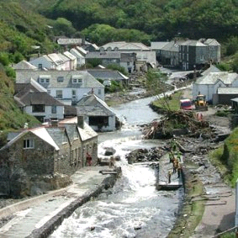

(i) Describe the effects of the floods shown in the photograph above.

.....................................................................................................................................

.....................................................................................................................................

.....................................................................................................................................

.....................................................................................................................................

.....................................................................................................................................

.....................................................................................................................................

.....................................................................................................................................

.....................................................................................................................................

(4)

ii) Explain **one** way in which river flooding may be prevented.

.....................................................................................................................................

.....................................................................................................................................

.....................................................................................................................................

.....................................................................................................................................

(2)

(Total 6 marks)

**7.** Describe the advantages and disadvantages of ‘soft engineering’ as a means of controlling flooding.

...............................................................................................................................................

...............................................................................................................................................

...............................................................................................................................................

...............................................................................................................................................

...............................................................................................................................................

...............................................................................................................................................

...............................................................................................................................................

...............................................................................................................................................

...............................................................................................................................................

...............................................................................................................................................

...............................................................................................................................................

...............................................................................................................................................

...............................................................................................................................................

...............................................................................................................................................

...............................................................................................................................................

...............................................................................................................................................

(Total 8 marks)

**Marks**

**1.** True False True 3

[3]

**2.** (i) Two correct labels with arrows (can be cross/dot, etc.), if no arrow  
label must clearly indicate the feature i.e. be written on it. 2

(ii) Velocity, deposit, banks, channel. 4

[6]

**3.** (i) Any 3 valid labels such as rapids / fast-flowing, gorge, narrow valley,  
interlocking spurs, plunge pool, steep sides, V-shaped valley,  
vegetation (qualified).  
(No reserved mark) 3

(ii) For waterfall, should refer to horizontal bands of hard and soft rock;  
the hard rock forming the cap rock; differential erosion via abrasion,  
hydraulic action will cause soft rock to wear away faster than the  
hard rock; this will be undercut and an overhang will form and collapse –  
the water plunging over the steep drop.  
Any valid sequence of waterfall formation is permissible.

**Level 1 (1-2 marks)**Basic statements with limited sequence *e.g. hard and soft rock  
appear next to each other, water flows steeply down hard rock.*

**Level 2 (3-4 marks)**Clear, more developed answer with more complete sequence  
and more appropriate terminology *e.g. hard rock lies on top  
of soft rock and is eroded faster due to the power of the water.  
This undercuts the hard rock which collapses forming the waterfall.*

**Level 3 (5-6 marks)**Detailed, well developed answer with clear and complete sequence;  
appropriate terminology *e.g. bands of hard and soft rock are horizontal;  
the overlying cap rock is eroded slower than the softer rock. Hydraulic  
action and abrasion are important processes of erosion. An overhang  
is formed which eventually collapses as the weight of the overlying  
cap rock is too great, creating the steep drop of the waterfall.  
May continue to retreat and formation of gorge.  
May add detail on process.* 6

[9]

**4.** Any valid label that fits the diagram and shows the sequence in the  
development of an ox-bow lake.  
First diagram – reference to river beginning to meander / fastest flow being  
towards developing outside bend.  
Second diagram – fastest flow on outside bend / results in erosion on this  
side of the channel and slower water on inside bend causes deposition.  
Third diagram – points for diagram 2 are valid if not previously made. Also,  
meander shifts and two outside bends get closer together as processes  
continue.  
Fourth diagram – Neck of meander is broken through, often in flood. River  
follows shortest course, leaving ox-bow lake without water. Deposition  
completes separation over time.

**Level 1 (Basic) 1–2 marks**Simple, listed points.  
Order not correct – jumps about.  
Sequence may be incomplete.  
Knowledge of basic information  
Simple understanding  
Few links; limited detail; uses a limited range of specialist terms  
Limited evidence of sentence structure. Frequent spelling, punctuation and  
grammatical errors.

**Level 2 (Clear) 3-4 marks**Points are developed and linked.  
Sequence and formation of ox-bow lake is clear.  
Knowledge of accurate information  
Clear understanding  
Answers have some linkages; occasional detail/exemplar; uses some  
specialist terms where appropriate  
Clear evidence of sentence structure. Some spelling, punctuation and  
grammatical errors. 4

[4]

**5.** (i) Correct labelling.  
Flood plain between 30m contour lines.  
Meander any with a bend on a river  
Tributary any small stream (don’t confuse with contour line of  
floodplain) 3

(ii) A (high) bank (of silt) on the river bank. 1

(iii) Corrasion; outside; migrate; floods. 4

[8]

**6.** (i) **Level 1 (Basic) 1-2 marks***Simple statements e.g. street flooded, debris, house partly gone, road  
washed away, tree debris, car crashed into buildings, car overturned,  
power line down.*

**Level 2 (Clear) 3-4 marks***Linked statements, better use of photo e.g. swollen river channel to  
right of photo; main street has a lot of debris and part is flooded; part  
of a property has been washed away and the inside paintwork can be  
seen, car overturned outside pink house, railings down on bridge.  
Two effects to achieve maximum marks. Costs of repair as developed  
point.* 4

(ii) 1 mark for the technique and 1 for explanation e.g. levees or artificial  
banks could be built up that would stop the river overflowing; dams  
could be built to store more water; trees could be planted to take in  
more water.  
(Just one technique and explanation)  
NOT floodwalls/flood defences/flood zoning/fences. 2

[6]

**7.** Actual content will depend on soft engineering methods selected.  
Likely to refer to flood warnings, preparation, flood plain zoning, ‘do  
nothing’ options.  
Will need to show an awareness of what these are e.g. the different levels  
of flood warning available, the restriction of certain land uses on parts of  
the flood plain etc. However, need to make clear what advantages and  
disadvantages of these methods e.g. For warnings that people have time  
to move possessions upstairs, get sandbags to front in time, evacuate.  
However, the threat remains and people are likely to be worried by it,  
suffer stress, have to claim for possessions / struggle to get insurance; for  
flood plain zoning that restricting building means that impermeable  
surfaces are not being created, so flood risk is not being increased and  
houses are not flooding. However, limiting building may limit expansion /  
jobs if there are no other suitable sites.

**Level 1 (Basic) 1–4 marks**Describes 1 or 2 soft engineering methods.  
Statements may be in a random order.  
Knowledge of basic information  
Simple understanding  
Few links; limited detail; uses a limited range of specialist terms  
Limited evidence of sentence structure. Frequent spelling, punctuation  
and grammatical errors.

**Level 2 (Clear) 5–6 marks**Begins to consider advantages or disadvantages.  
Refers to two methods, but may be imbalance.  
Statements are linked.  
Knowledge of accurate information  
Clear understanding  
Answers have some linkages; occasional detail/exemplar; uses some  
specialist terms where appropriate  
Clear evidence of sentence structure. Some spelling, punctuation and  
grammatical errors.

**Level 3 (Detailed) 7–8 marks**Advantages and disadvantages are both considered.  
Statements are linked and detailed.  
Refers to two methods – balance between them  
Greater balance between components.  
Knowledge of accurate information appropriately contextualised and/or at  
correct scale  
Detailed understanding, supported by relevant evidence and exemplars  
Well organised, demonstrating detailed linkages and the inter-relationships  
between factors  
Range of ideas in a logical form; uses a range of specialist terms where  
appropriate  
Well structured response with effective use of sentences. Few spelling,  
punctuation and grammatical errors.  
Level 3 does not always equate to full marks, a perfect answer is not  
usually expected, even for full marks. 8

[8]