Water on the Land

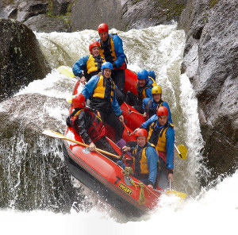
Contents
- River processes
- Long Profile
- Landforms
- Drainage basin system
- Hydrograph
- Flooding
- Boscastle
- Bangladesh 2004
- Hard soft engineering
- Water management in the UK

River processes
Erosion
Corrasion/Abrasion: The erosion of the river bottom and the riverbank by material being carried by the river itself.
Attrition: The rocks and pebbles being carried by the river crash against each other, wearing them down to become smaller, rounded pebbles.
Corrosion: The chemical erosion of the rocks of the riverbank by the slightly acidic water. This occurs in streams running through rocks such as chalk and limestone.
Hydraulic Action: The water forces air to be trapped and pressured into cracks in the rocks on the bank of the river. This constant pressure eventually causes the rocks to crack and break apart.
Transport
- Solution - minerals are dissolved in the water and carried along in solution.
- Suspension - fine light material is carried along in the water.
- Saltation - small pebbles and stones are bounced along the river bed.
- Traction - large boulders and rocks are rolled along the river bed.
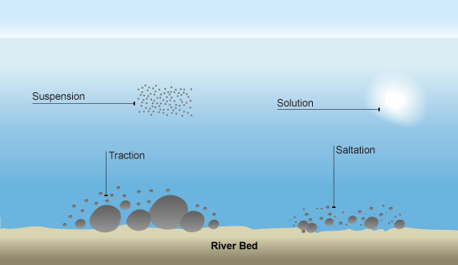

Deposition
When a river loses energy, it will drop or deposit some of the material it is carrying.
- Deposition may take place when a river enters an area of shallow water or when the volume of water decreases - for example, after a flood or during times of drought.
- Deposition is common towards the end of a river's journey, at the mouth.
- Long Profile of a river (how it changes from source the mouth)

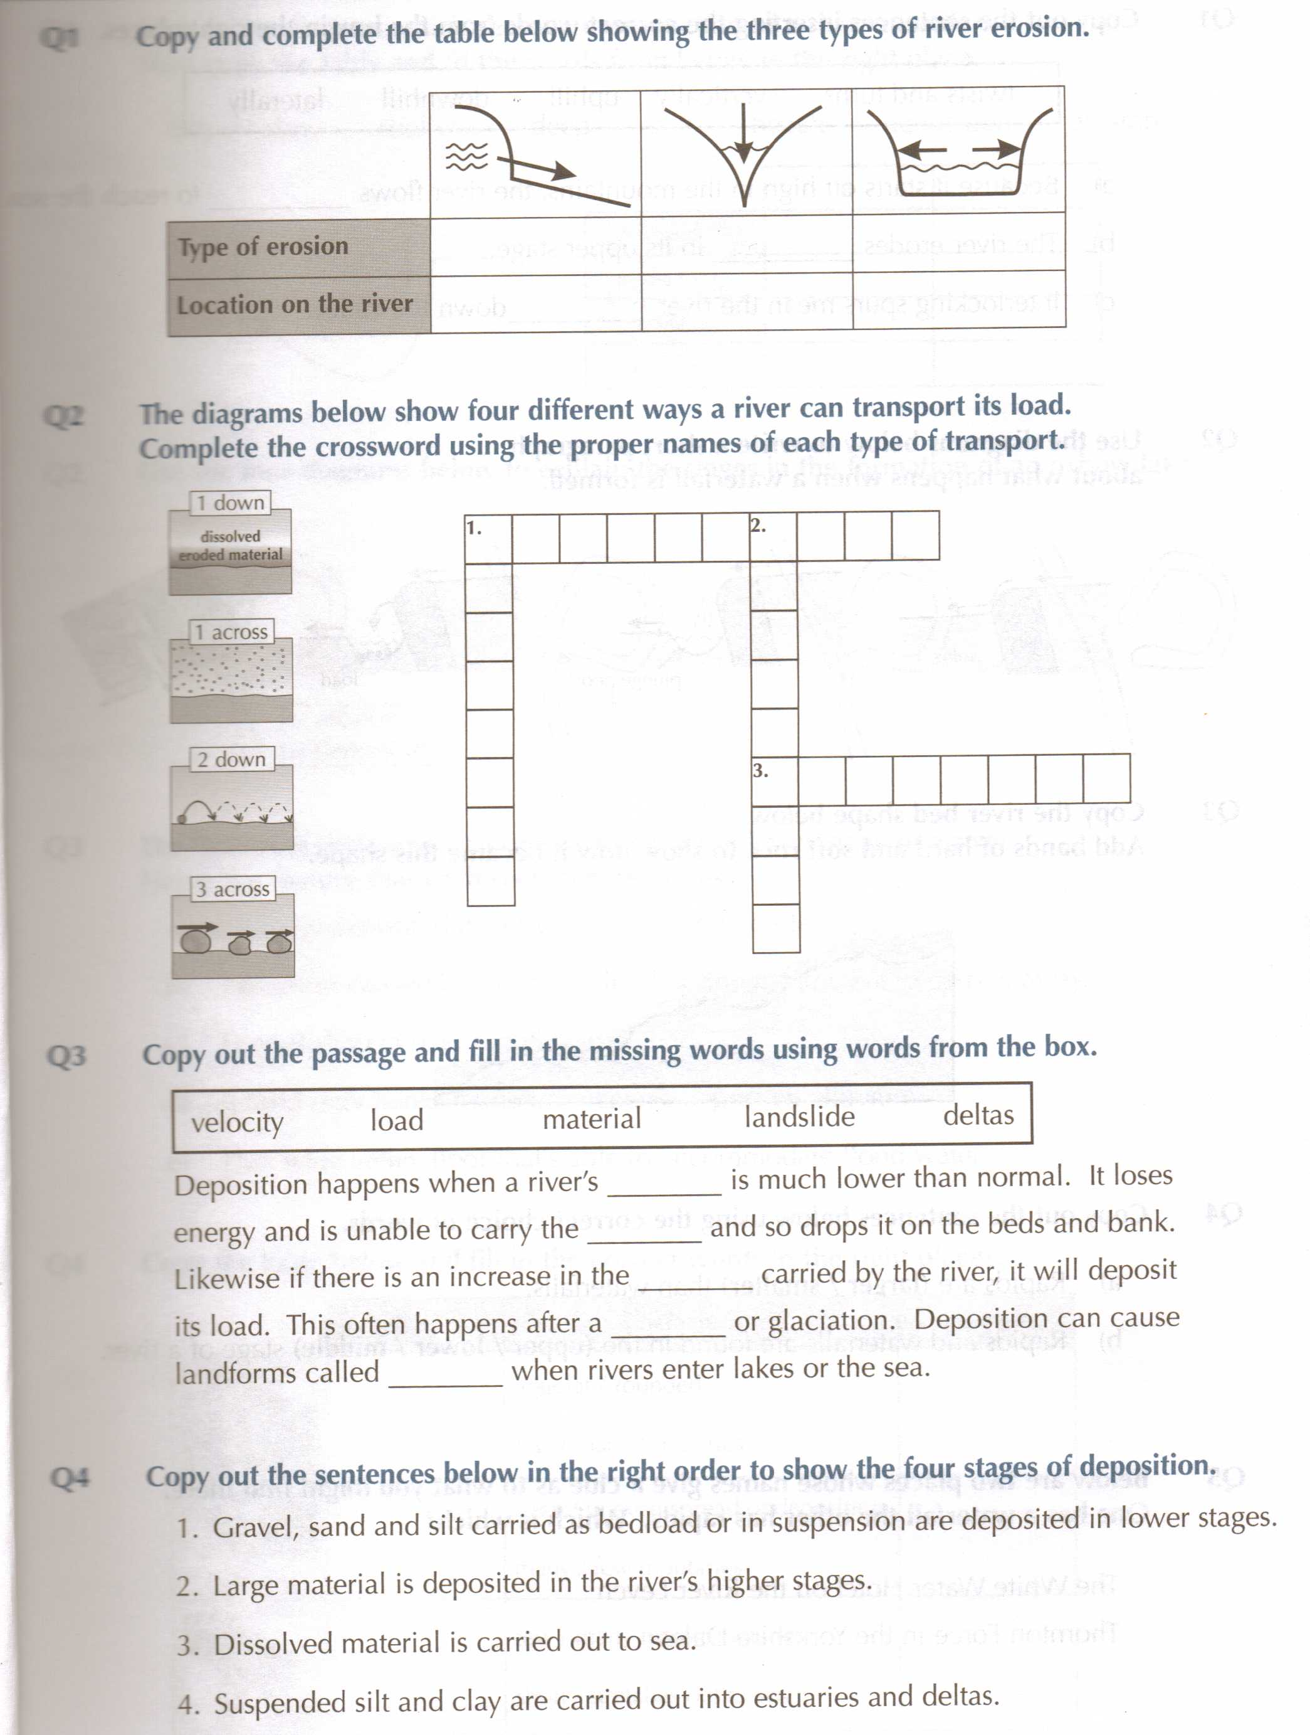
Long profile (from source to mouth).
The source of a river is often in an upland area. Near the source, a river flows over steep slopes with an uneven surface. It often flows over a series of waterfalls and rapids. Highland areas are usually composed of hard igneous rocks, which are ideal for forming such features.
As it flows down the steep slopes the water performs vertical erosion. This form of erosion cuts down towards the river bed and carves out steep sided V-shaped valleys.
As the river flows towards the mouth, the slopes become less steep. Eventually the river will flow over flat land as it approaches the sea.
The discharge (amount of water flowing) will increase as the river approaches the sea.

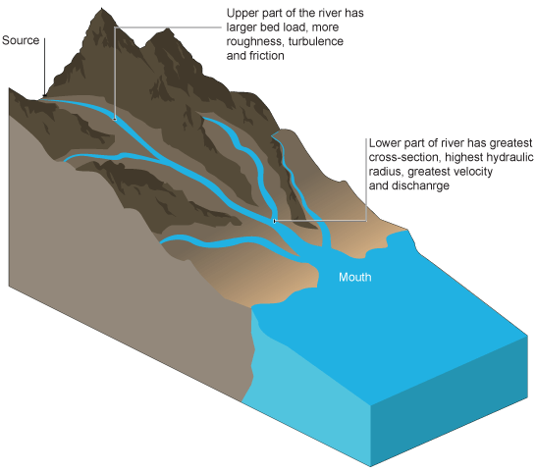

Cross profiles
Line across a river channel. The shape of the channel changes downstream
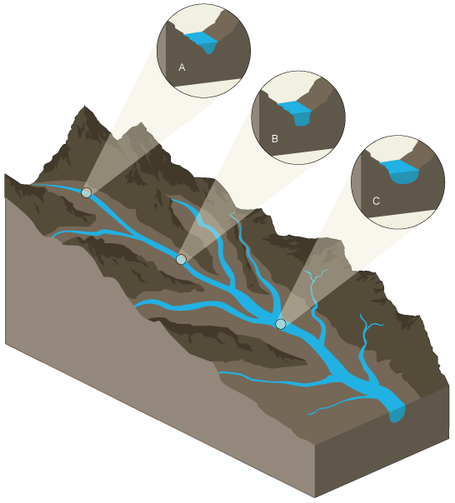

Near the source of a river there is more vertical erosion as the river flows downhill, using its energy to overcome friction (A). As a result the channels are narrow and shallow and may contain large boulders and angular fragments eroded and weathered from the steep valley sides. The sediment in the river creates turbulence and friction.
As the river approaches the mouth, velocity and energy increase due to increased discharge. The river performs more lateral erosion making the channel wider, and smoother (B) and (C). As a result there is less turbulence and friction, making the flow of water more efficient.

Summary

Upper Course | Mid Course | Lower Course
Features | Interlocking spurs, waterfalls, V-shaped valley, gorges. | Meanders, Slip-off slopes, ox-bow lakes. | Deltas, flood plains, levees, meanders, ox-bow lakes.
Velocity | Relatively slow moving. Despite areas of fast flowing water, the large amount of material on the river channel bed means that friction will slow the water down. | The water has increased in speed as the channel widens and becomes smoother. Some boulders cause friction to slow | The fastest section of the river, as the channel is widest, with very smooth sides, and the greatest volume of water.[/ulist]

Upper Course | Mid Course | Lower Course
Long Profile | Steeply sloping towards the lower sections of the river. | Shallow slopes towards the mouth of the river. | Almost at sea level, very gently sloping towards its mouth.
Cross Profile | Steep sided v-shaped valley. Thin river channel, deep in places. | V-shaped valley remains with a wider valley floor and the river begins to meander across it. The river channel begins to widen and become deeper. | Wide, shallow valley, with large flood plains and meanders. The river channel is wide, deep and smooth sided.

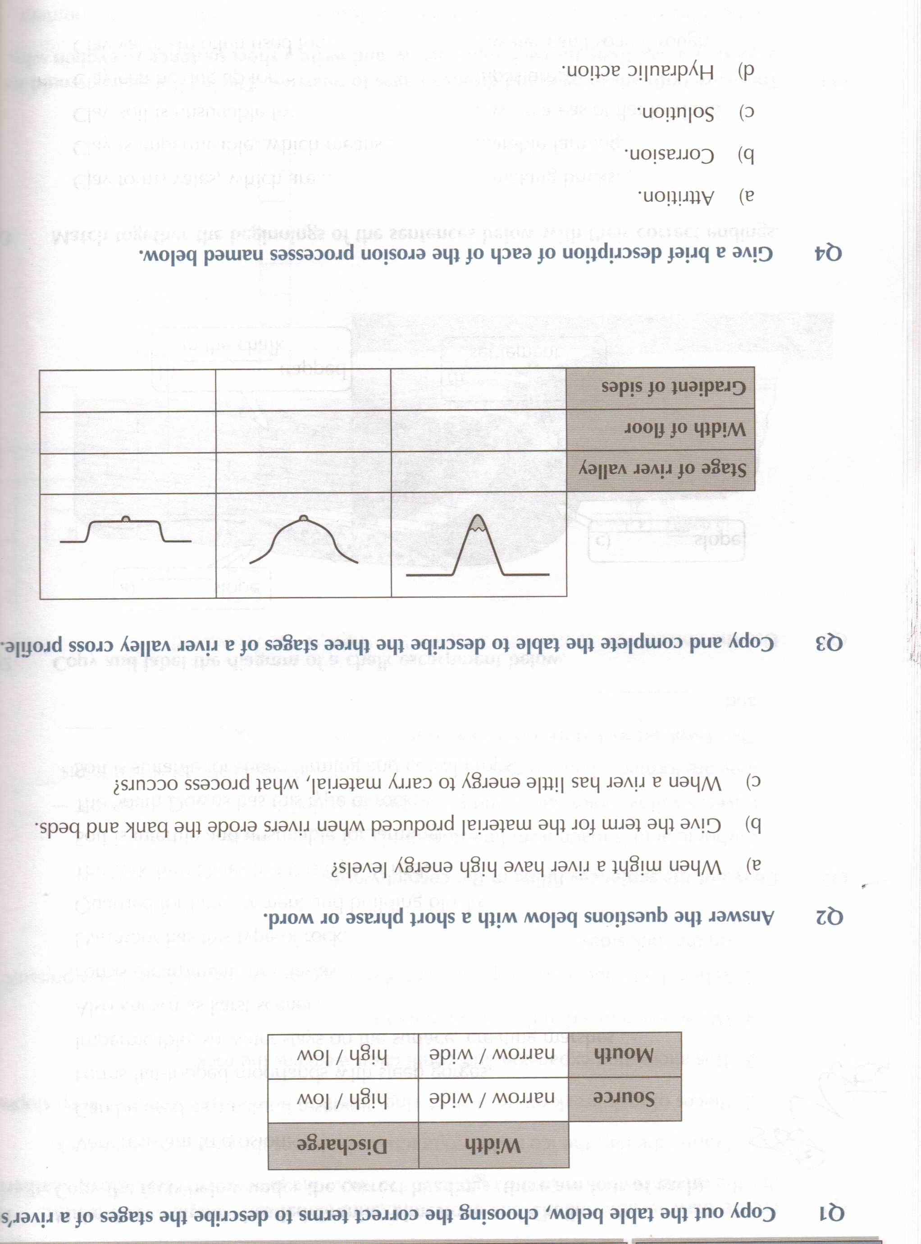
River Landforms

- Upper-course river features include steep-sided V-shaped valleys, interlocking spurs, rapids, waterfalls and gorges.

- Middle-course river features include wider, shallower valleys, meanders, and oxbow lakes.

- Lower-course river features include wide flat-bottomed valleys, floodplains and deltas.
Upper Course Features
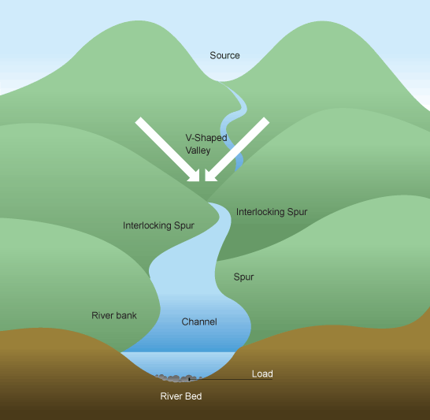

Interlocking Spurs - As the river cuts its deep V-shaped valley in its upper course, it follows the path of the easies trock to erode. Thus it tends to wind its way along, leaving the more resistant areas of rock as interlocking spurs.
V-shaped valleys - In the upper course of the river, it cuts rapidly downwards, as the river puts almost all of its energy towards cutting down to base level. This causes the most distinctive river feature, the V-shaped valley. Rocks and other material are washed into the river from the steep valley sides during times of heavy rainfall, adding to the material being carried by the river.
Waterfalls - Waterfalls are perhaps the most spectacular erosional feature of a river. They primarily occur in the upper course of the river. Often a waterfall will form where a band of harder rock lies over a softer one. As the river flows over the edge of the harder, more resistant rock, into its plunge pool, it erodes away the softer rock below, creating an overhang. Once the overhang is big enough the whole thing collapses due to gravity and its own weight. The whole process then occurs again. This means that over time waterfalls will move backwards up the valley, leaving a steep sided gorge in front of them.

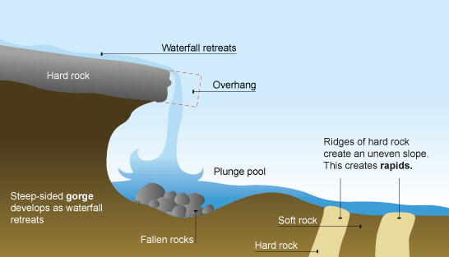

(see next page for a step by step guide)

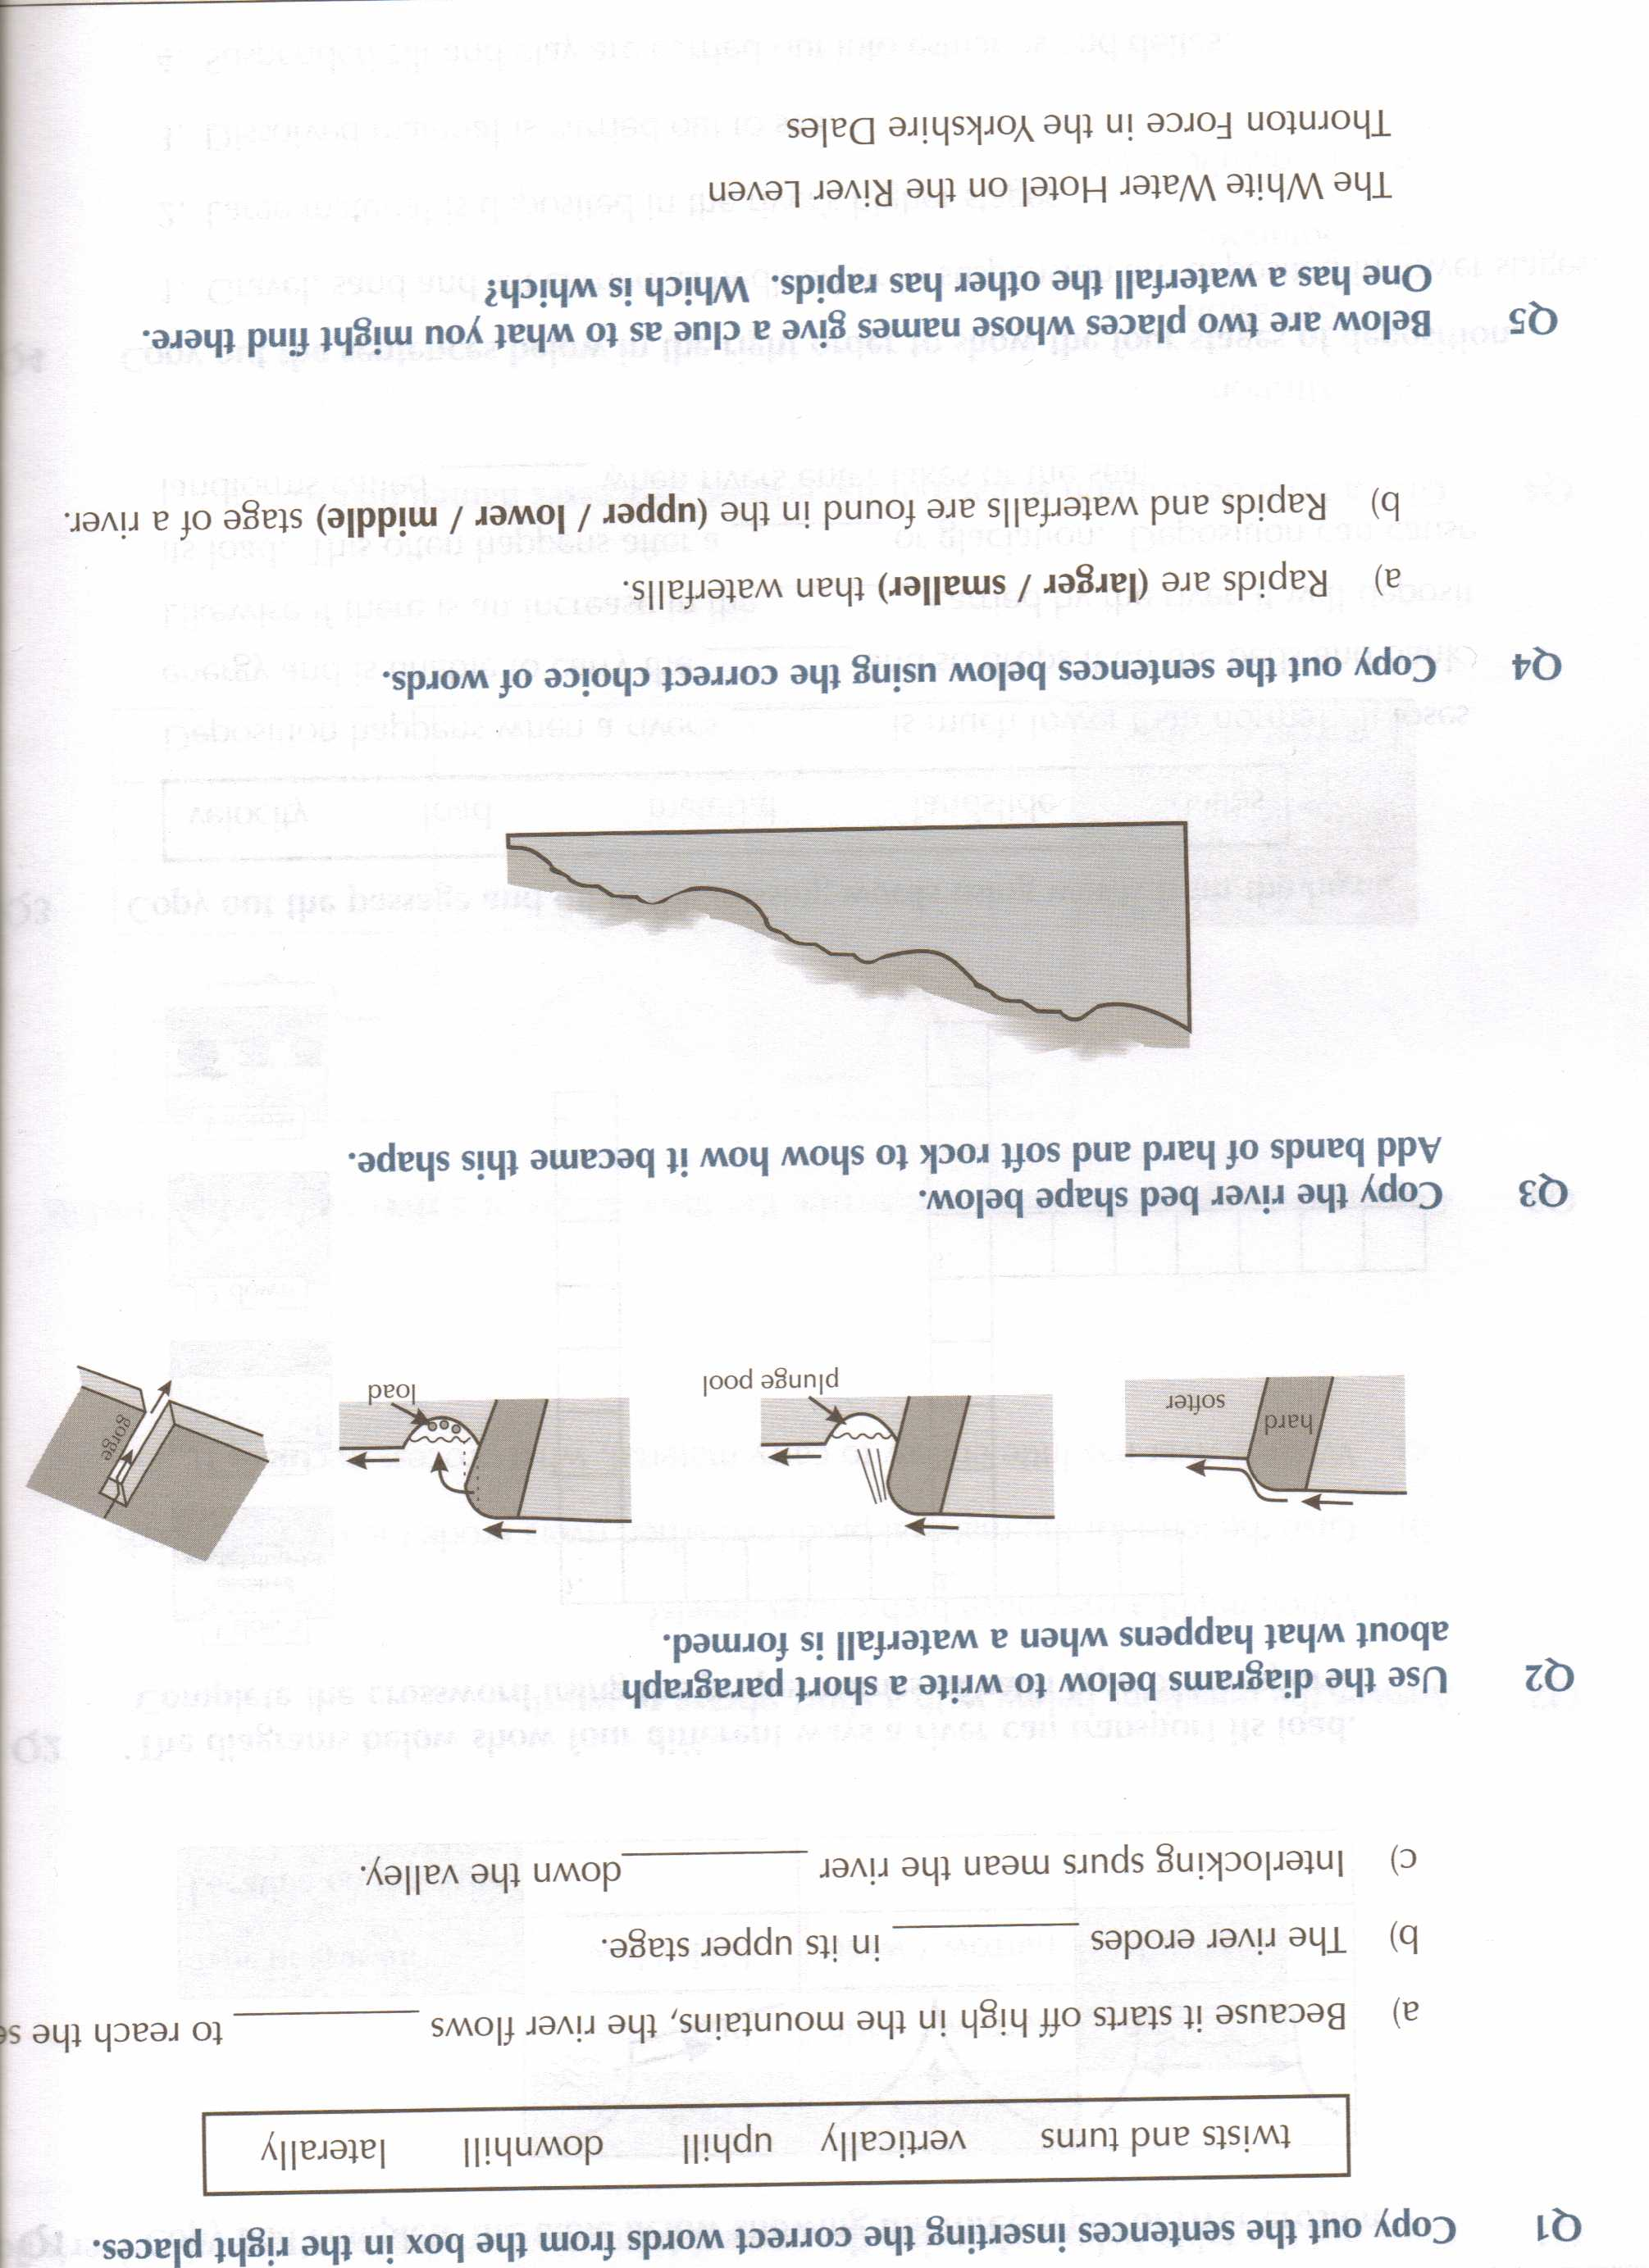
Meanders - Meanders occur in the mid course and lower course of the river, where it is beginning to cut laterally as it gets closer to base level. Meanders are basically bends in the river, where the faster water on the outside of the bend has cut into the bank, eroding it and creating a river cliff. At the same time the slow moving water on the inside of the bend deposits its load, building up a shallow slip-off slope. Meanders migrate downstream as they cut through the valley sides. This creates a line of parallel cliffs along the sides of the valley.

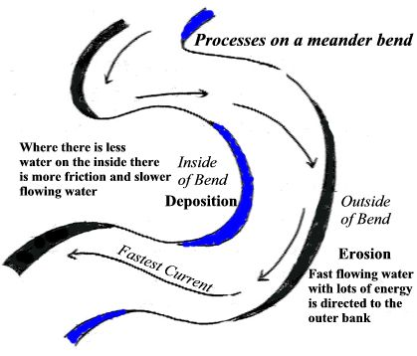

Ox-Bow Lakes - In the lower course of the river meanders can become so pronounced that they can form ox-bow lakes. In the lower course the rapid lateral erosion cuts into the neck of the meander, narrowing it considerably. Eventually the force of the river breaks through the neck, and as this is the easiest way for the water to go, the old meander is left without any significant amount of water flowing through it. Quickly the river deposits material along the side of its new course, which completely block off the old meander, creating an ox-bow lake.
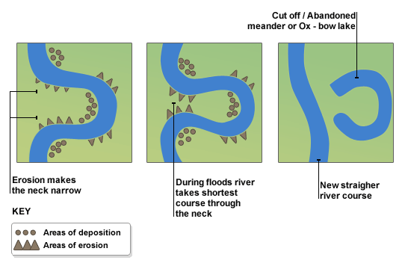

Flood Plain - The Flood Plain is the area of alluvial deposits found beside the river in its lower course. As meanders move slowly down the course of the river they erode away the valley to create a wide valley floor, and they deposit layers of alluvial material on the slip off slopes. Over time this builds up into a large flood plain. A very good example is the Canterbury Plains in New Zealand, where many large rivers have contributed to a huge area of alluvial deposition that has become prime agricultural land.
Levee's - Levees are naturally formed banks along the sides of a river channel in its lower course, as it flows through the flood plain. They are formed by the river depositing material when it floods. During a flood the river deposits its heaviest, coarsest material closest to its normal course. Over years this deposition has built up the natural embankments, built of coarse material. Beyond them the flood plain has been built up of the finer material that was deposited further away from the normal course of the river.
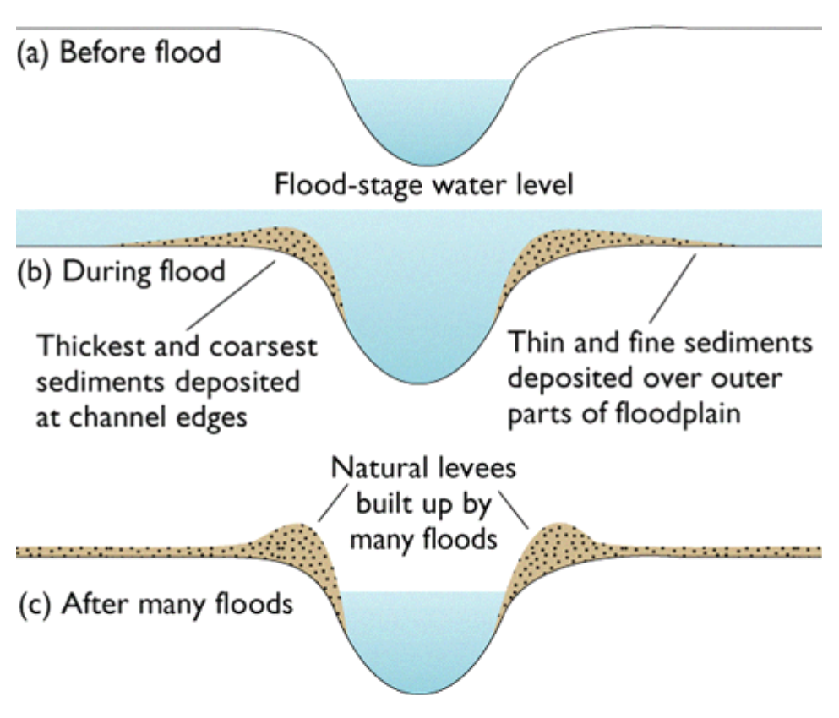

Deltas - Deltas occur where a river that carries a large amount of sediment meets a lake or the sea. This meeting causes the river to lose energy and drop the sediment it is carrying. Deltas form two types, called arcuate and birds foot. An arcuate delta is one, which builds out into the sea, extending the coast line, as the Nile Delta does in Egypt. A bird's foot delta is an extension of this as "fingers" of material from further off the edge of the delta. The delta of the Mississippi river shows these characteristics.

