Geography Revision
Water on the Land – Unit 1
The River Valley
- A path of a river as it flows downhill is called its course
- Rivers have an upper course (closest to the source), a middle course, and a lower course (closest to the mouth of the river)
- Rivers form channels and valleys as they flow
- They erode the landscape, then transport the eroded materials to someplace else with a slow stream to deposit it
- The shape of the valley and channel changes along the river depending on whether erosion or deposition is having the most impact.
- The long profile of a river shows you how the gradient changes over the different courses
- The cross profile shows the cross section of what a river looks like

Long Profile
Height
Lower Course
Middle Course
Upper Course

Source
Mouth

Course | Gradient | Valley shape | Channel Shape | Cross Profile
Upper | Steep | V-shaped valley, steep sides | Narrow, shallow
Middle | Medium | Gently Sloping valley sides | Wider, deeper
Lower | Gentle | Very wide, almost flat valley | Very wide, deep

The long profile does not show us what the river looks like, or how deep it is, or the amount of erosion taking places. However, it can show us waterfalls. For example, just before the middle course there is a large dip, this would most likely be a waterfall as it drops immediately after a relatively gentle slope.

Cross Profile
Erosion can be either vertical or lateral – both types happen at the same time but one is usually dominant over the other at different points along the river.
Lateral Erosion
This widens the river valley. It’s dominant in the middle and lower courses.
Vertical Erosion
This deepens the river valley, making it v-shaped. It’s dominant in the upper course of the river.

The Four Types of Erosion
Or as I like to remember it, the AHA’S:
- Abrasion – Eroded rocks picked up by the river scrape and rub against the channel, wearing it away. Most erosion happens by abrasion
- Hydraulic action – The force of the water breaks rock particles away from the river channel
- Attrition – Eroded rocks picked up by the river smash into each other and break into smaller fragments. Their edges also get rounded off as they rub together.
- Solution – The River dissolves some types of rocks (chalks etc...)
The Four Types of Transport
Or as I like to remember it, The Three S’s (Transport, Traction, Solution, Saltation and suspension)
- Traction – large particles like boulders are pushed along the river bed by the force of the water
- Saltation – pebble sized particles are bounced along the river bed by the force of water
- Suspension – small particles like silt and clay are carried along by the water
- Solution – soluble materials dissolve in the water and are carried along.
Deposition
- Deposition is when a river drops the eroded material it’s transporting
- It happens when a river slows down (loses velocity)
- There are a few reasons why rivers slow down and deposit material:
  - The volume of water in the river falls
  - The amount of eroded material in the water increases
  - The water is shallower, e.g. on the inside of a bend
  - The river reaches its mouth
River Landforms
Upper- course river features include steep-sided V-shaped valleys, interlocking spurs, rapids, waterfalls and gorges.
Middle- course river features include wider, shallower valleys, meanders, and oxbow lakes.
Lower- course river features include wide flat-bottomed valleys, floodplains and deltas.
Upper Course Landforms
Waterfalls and Gorges
- Waterfalls form where a river flows over an area of hard rock followed by an area of softer rock.
- The softer rock is eroded more than the hard rock, creating a ‘step’ in the river.
- As water goes over the step it erodes more and more of the softer rock
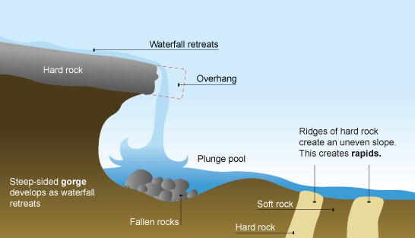
- A steep drop is eventually created, which is called a waterfall
- The hard rock is eventually undercut by erosion. It becomes unsupported and collapses
- The collapsed rocks are swirled around at the foot of the waterfall where they erode the softer rock by abrasion. This creates a deep plunge pool.
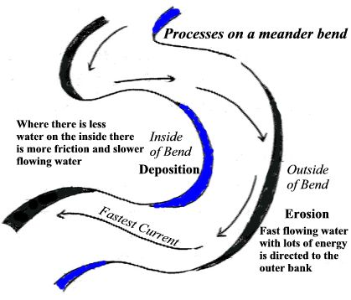
Middle Course Landforms
Meanders
These are always formed in the middle and lower courses.
- The current (the flow of the water) is faster on the outside of the bend because the river channel is deeper.
- So more erosion takes place on the outside of the bend, forming rive cliffs
- The current is slower on the inside of the bend because the river channel is shallower (There’s more friction to slow the water down)
- So eroded material is deposited on the inside of the bend, forming slip-off slopes
Ox-bow lakes
These are formed by meanders. Meanders get larger over time with more erosion and deposition occurring creating an…. Ox Bow Lake!
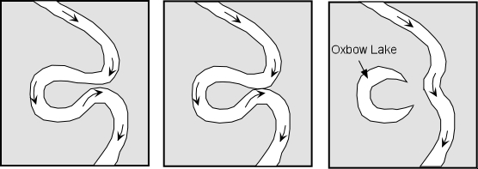
- Erosion causes the outside bends to get closer until there’s only a small bit of land left between the bends (called the neck)

2) The river breaks through this land, usually during a flood and the river flows along the shortest course
3) Deposition eventually cuts off the meander forming an ox-bow lake

Lower Course Landforms
Flood plains
1) This is the wide valley floor on either side of a river which occasionally gets flooded.
2) When a river floods onto the flood plain, the water slows down and deposits the eroded material that it’s transporting. This builds up the flood plain (makes it higher)
3) Meanders migrate across the flood plain, making it wider
4) The deposition that happens on the slip-off slopes of meanders also builds up the flood plain
5) These plains are very fertile, and amazing for farmers, although they flood regularly

Levees
These are natural embankments along the edges of a river channel. During a flood, eroded material is deposited over the whole flood plain. The heaviest material is deposited closest to the river channel, because it gets dropped first when the river slows down. Over time, the deposited material builds up, creating levees along the edges of the channel, e.g. along the yellow river in China.
River Discharge
River discharge is simply the volume of water that flows in a river per second. It’s measured in cumecs (cubic metres per second). Hydrographs show how the discharge at a certain point in a river changes over time. Storm hydrographs show the changes in river discharge around the time of a storm.
1) Peak Discharge – The highest discharge in the period of time you are looking at.
2) Lag Time – the delay between peak rainfall and peak discharge.
3) Rising Limb – The increase in river discharge as rainwater flows into the river
4) Falling Limb – The decrease in river discharge as the river returns to its normal level
Lag time happens because most rainwater doesn’t land directly in the river channel – there’s a delay as rainwater gets to the channel. It gets there by flowing quickly overland (called surface runoff), or by soaking into the ground (called infiltration) and flowing slowly underground.
Things that Effect River Discharge
Urban areas have drainage systems and they’re covered with impermeable materials like concrete, these increase runoff. Lag time is decreased, so discharge increases.
Amount of rainfall – Lots of rain and short heavy periods of rainfall means there’s more runoff. Lag time is decreased, so discharge increases.
Previous weather conditions – Saturated soil means it is fully clogged and therefore almost hard areas, making a shorter lag time and a higher discharge.
Trees and vegetation – an area surrounded by vegetation will take in the water, or at least block its path to the river. This increases lag time and decreases discharge.
Temperature – on a hot day with dry conditions, or cold freezing days, the ground is very hard. This increases runoff, lag time is decreased so discharge increases
Relief – lots of runoff occurs on steep slopes. Lag time is decreased so discharge increases.
Rock type – Water infiltrates through pore spaces in permeable rock and flows along cracks in pervious rocks – this means there isn’t much runoff. Lag time is increased, so discharge decreases. Lag time is decreased, so discharge increases.

Flooding
A river is likely to flood when the graph’s line is steep. This is because there is a rapid increase in discharge over a short period in time. Floods can cause extensive damage. Flooding notoriously hits LEDC’s harder than MEDC’s. This is because they have worse education of how to deal with floods, worse warnings and not enough defensive measures in place to handle the floods. The main causes of flooding is concreting land (making it impermeable and therefore increasing run off), and deforestation (getting rid of the trees that take in the rain water, slowing down its process towards the river)
You should know how flooding impacts society, economy and political issues from your case studies, but here is a quick and obvious recap.
Negative
- Flooding destroys homes
- Flooding destroys businesses
- Ruins paperwork and important files
- Shuts down schools
- Contaminates water supplies
- (In poor places especially) Makes land inhabitable
Positive
- Fertile land for agriculture
- People living near or on flood plains rely upon regular flooding to help support farming and therefore provide food
Flood Control
Flood management techniques can be divided into hard and soft engineering options. Hard options tend to be more expensive and have greater impact on the river and the surrounding landscape. Soft options are more ecologically sensitive.
Soft engineering
1) Trees planted near to the river, this means greater interception of rainwater and a lower river discharge (afforestation)
2) Do nothing – people should accept they live in a highly dangerous area
3) Flood plain zoning – restrictions to prevent building on flood plains, lowering building damage
4) Flood warnings and preparations – Warnings about floods to allow people to put sand bags were necessary and buildings are modified to be water proof
Hard engineering
1) Dams are often built along the curse of a river in to control the amount of discharge. Water is held back by the dam and released in a controlled way, controlling flooding.
2) Water is usually stored in a reservoir behind the dam. This water can then be used to generate hydroelectric power.
3) Widening or deepening the river channel in order to make it carry more water, or the river is straightened so that the water flows faster, meaning discharged water is quickly removed from the rain sit.

Managing the UK’s water
In the UK, the places with a good supply of water aren’t the same as the places with the highest demand. These graphs show how the highest population density isn’t in the places where the most rainfall occurs; in fact it’s almost the complete opposite way around. So how do we get the water to the population?
Population Density
Average annual rainfall
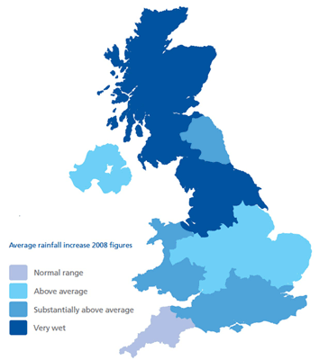
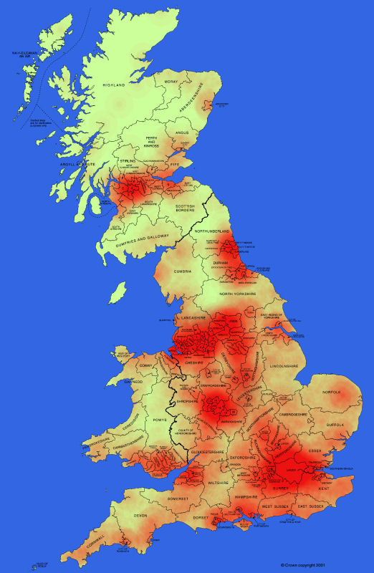

1) The north and west of the UK have a high rainfall, but low density.
2) The south-east and the midlands have a high density but relatively low rainfall.
How to deal with the supply and demand problem
Water supplies can be damaged by various kinds of pollution, and this can have a damaging impact on the environment and human health. In all countries demand for water is growing:
1) As technology and industry advance the demand for water grows
2) As LEDC’s industrialise and urbanise their demand for water grows.
3) Most MEDC’s are becoming wealthier and so people are spending more money on technology and increasing the demand for water
One way to deal with the supply and demand problem is to transfer water from areas of surplus to areas of deficit. Water transfer can cause a variety of issues such as it can affect the wildlife that lives in the river.
Reducing demand for water
People can reduce the amount of water that they use at home, e.g. taking showers instead of baths. Also, water companies want people to have water meters installed to measure the amount of water they use, making them more aware of wastage.

