AS Skills

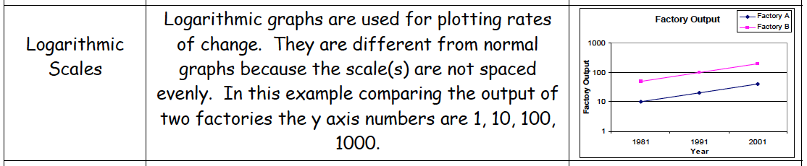
All statistics used in this booklet are real and should be quoted in your exam

Task 1

Magnitude is a logarithmic scale. An earthquake that is 7 on the Richter scale is 10 times larger than an earthquake that measures 6 on the Richter scale. Complete the following graph to illustrate the magnitude of the following earthquake (don’t forget to label the graph!):

Earthquake | Magnitude on Richter Scale
Kobe, 1995 | 7.2
Linconshire, 2008 | 5.2
Haiti, 2010 | 7
Boxing Day Indonesian Tsunami, 2004 | 9.1
Bam, 2003 | 6.6

Task 2

Draw a logarithmic graph to show the number of people living with HIV/AIDs in the following countries:

Country | Number of People living with HIV/AIDs
South Africa | 5,600,000
Zambia | 980,000
Malaysia | 100,000
Libya | 10,000
Iceland | 1,000

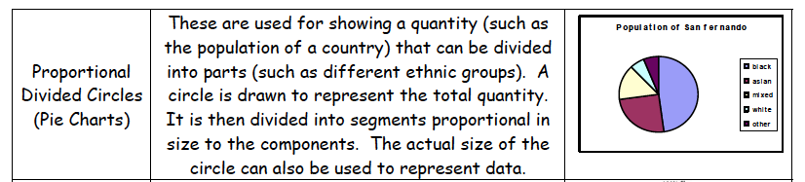

Task 3

Create a ‘Proportional Divided Circle’ to display the following information:

BMI Category | % of Year 6 Children in each BMI Category according to National Child Measurement Program (UK)
Underweight | 1.3
Healthy Weight | 66.1
Overweight | 14.3
Obese | 18.3

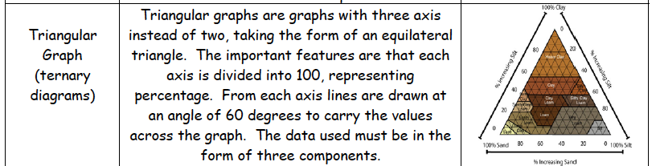

Task 4

Create a Triangular Graph to show the following
information:

Ward in Stockton-On-Tees | % Population who own their property outright or with a loan or mortgage | % Population who rent their property from the council | % Population- Other
Charltons | 61.14 | 26.55 | 12.31
Egglescliffe | 89.06 | 3.07 | 7.87
Maltby | 67.57 | 16.47 | 15.99

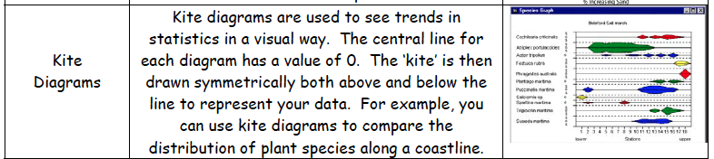
Task 5

Answer the following questions using the Kite Diagram below.

- Which species is most prevalent up to 2 metres from the shore?

- What species is the most common in the sample shown in the Kite Diagram?

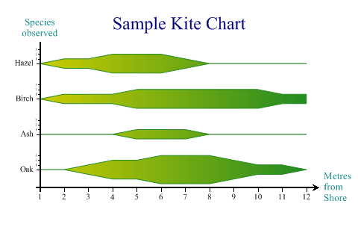
- Which 2 species can be found 9 metres away from the shore?

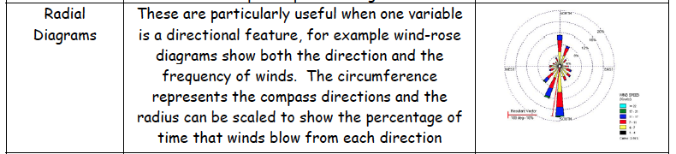
Task 6

Answer the following questions using the Radial Diagram below.

- What is the Theoretical DCIE?

- What is the Average DC Utilization?

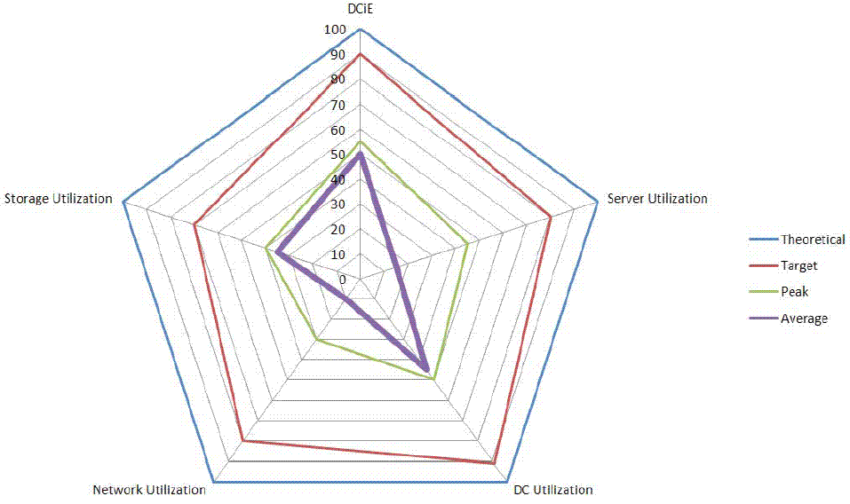
- What is the Target Storage Utilization?

[Disclaimer- Do not ask me what this graph is showing- I have no clue!]

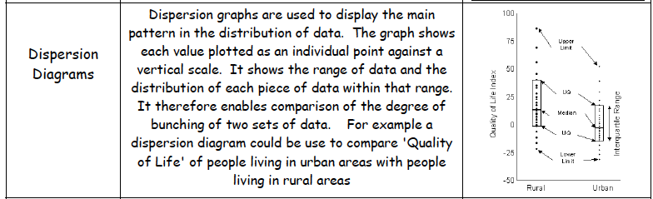
Task 7

Use the data on the next page to complete the dispersion diagram showing famines of the last 10 years. Data relating to Bangladesh and Somalia have already been added.

Area affected by Famine | Zimbabwe
 | Sudan
 | Malawi
 | Niger
 | Somalia
 | Dijibouti
 | Ethiopia
 | Kenya
 | Afghanistan
 | Bangladesh
 | East Africa
 | Tajikistan
 | Sahel
 |  | Frequency of Famines in the Past 10 Years

2000–2009 | Zimbabwe's food crisis caused by Mugabe's land reform policies[85] | Zimbabwe
2003 | Famine in Sudan/Darfur (Darfur conflict) | Sudan
2005 | 2005 Malawi food crisis | Malawi
2005-2006 | 2005–06 Niger food crisis | Niger
2006 | 2006 Horn of Africa food crisis | Somalia, Djibouti, Ethiopia and Kenya
2008 | Myanmar food crisis. Cyclone Nargis devastated Burma's major rice-producing region.[86] | Myanmar
2008 | North Korean food crisis[87][88] | North Korea
2008 | Horn of Africa food crisis[89][90] | Somalia, Ethiopia and Kenya
2008 | Afghanistan food crisis[91] | Afghanistan
2008 | Bangladesh food crisis[92] | Bangladesh
2008 | East Africa food crisis[93] | East Africa
2008 | Tajikistan food crisis[94] | Tajikistan
2009 | Kenya food crisis[95] 10 million Kenyans face starvation.[96] | Kenya
2010 | Sahel food crisis [97] | Sahel
2011 | Horn of Africa[98] | Somalia and neighbouring countries

